PLEASE fill out this survey and return it with the backpack on Monday:

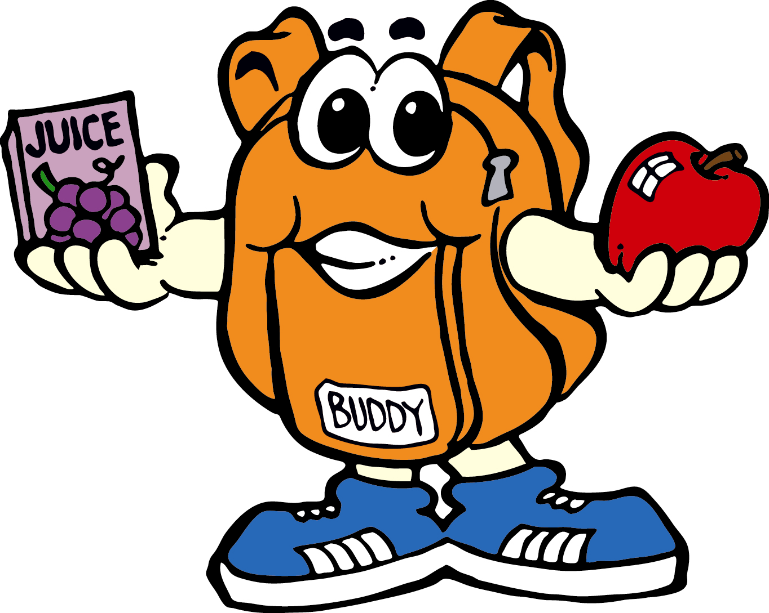

Since your child has started receiving a backpack full of food every week, how has this helped your family’s financial situation?

____a lot ____a little ____not at all ____I’m not sure

What are your child’s favorite foods in the backpack?

What food would you like to be added to the backpack?

How long does the food in the backpack last?

____Friday night ____Saturday ____Sunday ____Monday

Our household consists of _____ adults and ________ children

When your child brings home food in a backpack every Friday, do you find it?

____embarrassing ____helpful ____unnecessary

2014/15

