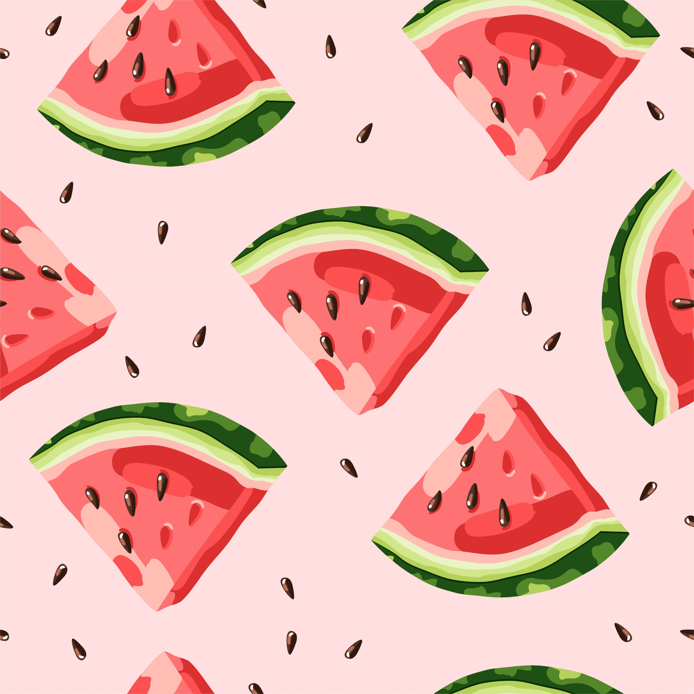Summer 2023

Rotating Lunch Menu

**Monday**

|  |  |  |  |  |
| --- | --- | --- | --- | --- |
| **Cranberry Chicken Salad – 3 oz**  **WG Captain’s Crackers – 2 packets each**  **Green Salad – 1 cup**  **Fresh Orange - 1 each**  **Skim Milk – 8 fl. oz.** | **TACO TUESDAY**  **Beef & Bean Crunchy Tacos**  **WG taco shells - 2 each**  **Mexicorn - 1/2 cup**  **Fresh Apple - 1 each**  **Skim Milk – 8 FL oz** | **Spaghetti Bolognese- 3 oz**  **WG Spaghetti – 2 oz**  **Italian Cucumber Salad – ½ cup**  **Fresh Grapes – ½ cup**  **Skim Milk – 8 fl. Oz.** | **Rotisserie Chicken – 1 each**  **Honey Wheat Roll – 1 each**  **Kevin’s Baked Beans – ½ Cup**  **Fresh Pineapple – ½ cup**  **Skim Milk – 8 fl. Oz.** | **Buffalo Chicken Enchilada Dip – ½ cup**  **WG Tortilla Chips – 1 oz**  **Fresh Corn Salad – ½ Cup**  **Fresh Banana – 1 each**  **Skim Milk – 8 fl. Oz.** |
| **Chicken Fajita Soft Tacos w peppers and onion**  **2 oz each**  **Shredded cheese – ½ oz**  **WG Flour tortilla – 2 each**  **Corn Cobbette – 1 each**  **Fresh Apple – 1 each**  **Skim Milk – 8 fl. Oz.** | **Spicy Cajun Chicken & Pasta**  **4 oz pasta/chicken**  **WG Penne – ½ cup**  **Scandinavian Veg – ½ cup**  **Fresh Strawberries – 1 each**  **Skim Milk – 8 fl. Oz.** | **Cheeseburger- 1 each**  **WG Bun – 1 each**  **Cole Slaw – ½ cup**  **Fresh Watermelon – ½ cup**  **Skim Milk – 8 fl. oz.** | **Beef Taco Salad – 3 oz taco meat, lettuce, cheese, tomatoes**  **WG Tortilla Chips – 1 oz**  **Green Salad – 1 Cup**  **Fresh Grapes – ½ Cup**  **Skim Milk – 8 fl. Oz.** | **BBQ Chicken- 1 each**  **Honey Wheat Roll – 1 each**  **Southern Style Green Beans – ½ cup**  **Fresh Orange – ½ Cup**  **Skim Milk – 8 fl. Oz.** |
| **Mediterranean Roasted Chicken Quarters – 3 oz**  **Honey Wheat Roll – 1 each**  **Italian Blend Veg – ½ cup**  **Fresh Orange – 1 each**  **Skim Milk – 8 fl. Oz.** | **Asian Chicken Salad w/ Mandarins & Chow Mein Noodles**  **2 oz chicken**  **WG Education Crackers – 1 oz**  **Green Salad – 1 cup**  **Fresh Apple – 1 each**  **Skim Milk – 8 fl. Oz.** | **Philly Cheesesteak**  **4 oz meat and veg mix**  **WG Bun – 1 each**  **Baby Carrots – ½ Cup**  **Fresh Berries – 1 each**  **Skim Milk – 8 fl. Oz.** | **Penne Bolognese**  **3 oz sauce and meat**  **WG Spaghetti – ½ cup**  **Italian Cucumber Salad – ½ cup**  **Fresh Banana – 1 each**  **Skim Milk – 8 fl. Oz.** | **Chicken Soft Tacos w/shredded cheese – 2 oz chicken, ½ oz cheese, lettuce, tomatoes**  **WG Tortillas – 2 each**  **Fresh Corn Salad (Esquites) – ½ cup**  **Fresh melon – ½ cup**  **Skim Milk – 8 fl. Oz.** |
| **Cheeseburger- 1 each**  **WG Bun – 1 each**  **Potato Wedges – ½ cup**  **Fresh Apple – 1 each**  **Skim Milk – 8 fl. oz.** | **Taco Tuesday**  **Beef & Bean Crunchy Tacos**  **WG taco shells - 2 each**  **Mexicorn - 1/2 cup**  **Fresh Orange -1 each**  **Skim Milk – 8 FL oz** | **SW Chicken Salad (cold) w/ black beans and corn salsa – 2oz chicken, 1 oz black beans and corn**  **WG Crackers – 1 oz**  **Green salad – 1 Cup**  **Fresh Banana – 1 each**  **Skim Milk – 8 fl. oz.** | **Smokey Chicken Quarter- 1 each**  **WG Macaroni Salad – ½ cup**  **Corn Cobbette – 1 each**  **Fresh Grapes – ½ Cup**  **Skim Milk – 8 fl. oz.** | **Breaded Chicken Sandwich - 1 each; 1 slice American cheese**  **WG Bun – 1 each**  **Fresh Celery – ½ cup**  **Fresh Berries – ½ Cup**  **Skim Milk – 8 fl. oz.** |

**Tuesday**

**HAPPY SUMMER!!**

**Wednesday**

**Thursday**

Ages: 6-18

**Fri**