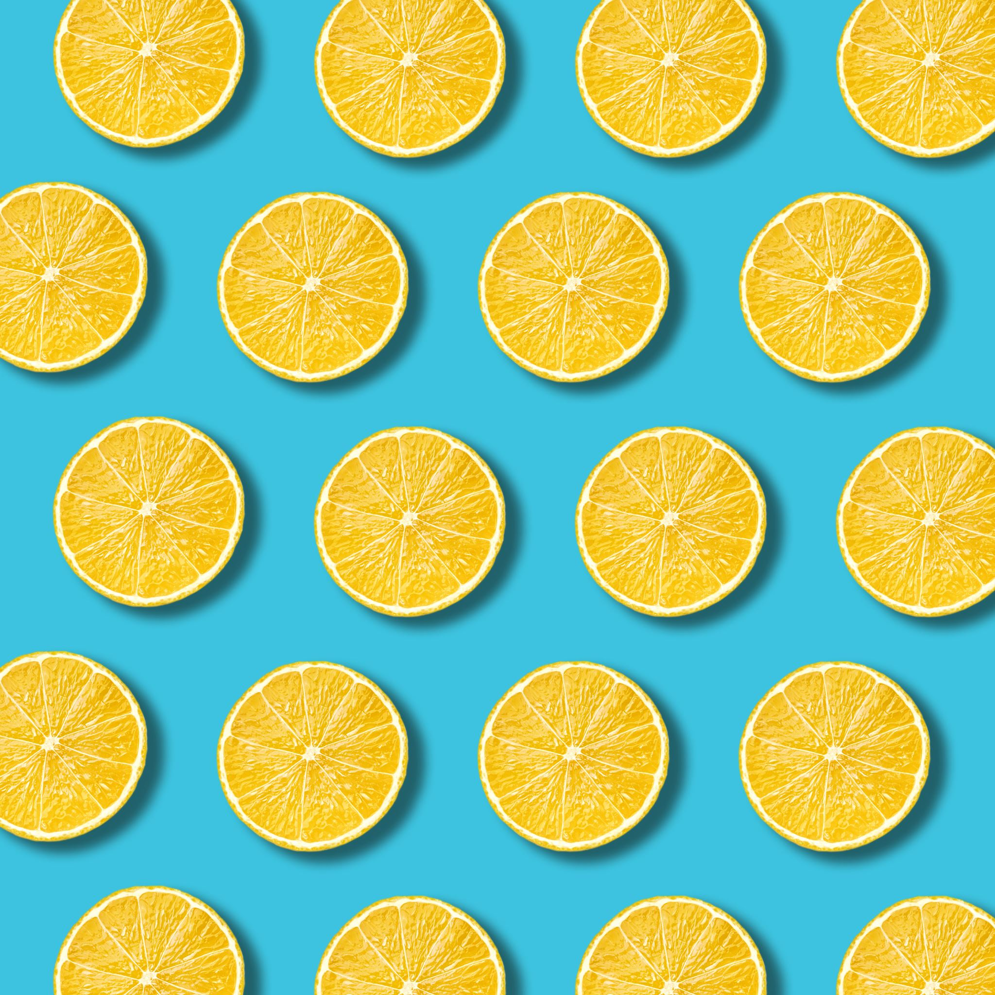Rotating PM Snack Menu

Summer 2023

**Monday**

**Tuesday**

**Wednesday**

**Thursday**

Ages: 6-18

**Friday**

|  |  |  |  |  |
| --- | --- | --- | --- | --- |
| WG Bagel  Cream Cheese  Cucumber Slices  Ranch  Fresh Banana  Juice | WG Bulk Tortilla Chips  Baby Carrots  Ranch  Fresh Orange  Juice | Colby Jack Cheese Sticks  WG Bulk Pretzels  Fresh Apple  Juice | WG Triple Berry Crunch Snack Bar  Bulk Goldfish  Fresh Pear  Juice | Hummus  WG Pita Bread  Fresh Plum  Juice |
| Yogurt  WG Muffin  Fresh Orange  Juice | Cheddar Cheese Cubes  WG Crackers  Fresh Banana  Juice | Cheese Cup  WG Pretzels  Fresh Plum  Juice | |  |  | | --- | --- | | WG Granola Bar  Baby Carrots  Ranch  Fresh Apple  Juice | 6  Meatball Sub—2 oz.  WG Bun—1 each  Broccoli & Cheese—1/2 cup (FZ)  Pineapple – 4 oz. (FR)  Skim Milk—8 fl. oz. | |  |  | | |  |  | | --- | --- | | Sunbutter & Jelly Sandwich  Bulk Goldfish  Fresh Pear  Juice | 6  Meatball Sub—2 oz.  WG Bun—1 each  Broccoli & Cheese—1/2 cup (FZ)  Pineapple – 4 oz. (FR)  Skim Milk—8 fl. oz. | |

