

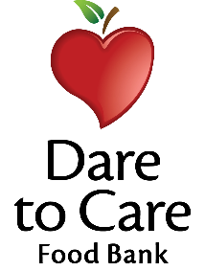

Snack Menu

Monday:
Grilled Chicken Nuggets - 2.6oz
Cinnamon Grahams - 1oz
Welch’s Fruit Snacks - .9oz
Capri Sun 100% Juice - 6oz

Tuesday:
Roast Turkey Sandwich - 2oz
Wheat Bread – 2 slices
Carrot Sticks - 2oz (FR)
Welch’s Fruit Snack - .9oz
Capri Sun 100% Juice - 6oz

Wednesday:
Smoked Turkey Ham Sandwich – 2 oz.
Wheat Bread – 2 slices
Goldfish Crackers -.75oz
Fresh Apple Slices - 2oz (FR)
Capri Sun 100% Juice - 6oz

Thursday:
Roast Turkey - 2oz & Cheese - 1/4 oz
Wrap – 1 each
Cheezit Crackers - .75oz
Strawberry Gogurt - 2oz
Capri Sun 100% Juice - 6oz

Friday:
Grilled Chicken - 2.8oz
Wheat Bun – 1 each
Pretzel Twists - .5oz
Applesauce Cup - 4oz
Capri Sun 100% Juice - 6oz

