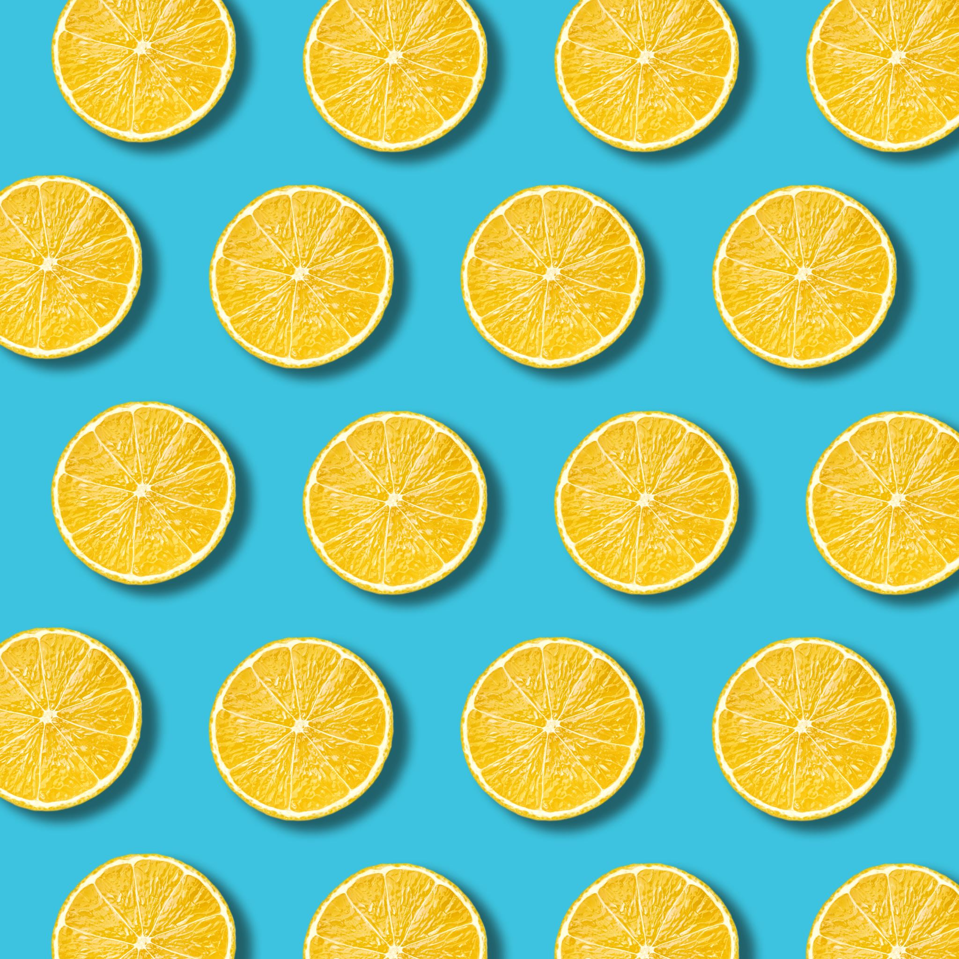
PM Snack

Monday

Tuesday

Wednesday

Thursday
Ages: 6-18

Friday

Beef N Bean Burrito  Fresh Apple  Juice  1x Mild Taco Sauce Packet | Cheese Cup  WG Pretzel  Fresh Nectarine  Juice | String Cheese x 2  WG Graham Crackers  Fresh Plum  Juice | Grilled Chicken Sandwich  WG Bun  Fresh Clementine  Juice  1x BBQ Sauce Packet | Shelf Stable Lunch Kit – Variety
Chicken Taquitos x 2  Fresh Clementine  Juice  1x Milk Taco Sauce Packet | Yogurt  Granola Bar x 2  Fresh Plum  Juice | Soybutter Uncrustable  WG Cheez-It  Fresh Apple  Juice
  Turkey & Cheese Sandwich  WG Bun  Fresh Nectarine  Juice | 6  Meatball Sub—2 oz.  WG Bun—1 each  Broccoli & Cheese—1/2 cup (FZ)  Pineapple – 4 oz. (FR)  Skim Milk—8 fl. oz.
  Shelf Stable Lunch Kit – Variety | 6  Meatball Sub—2 oz.  WG Bun—1 each  Broccoli & Cheese—1/2 cup (FZ)  Pineapple – 4 oz. (FR)  Skim Milk—8 fl. oz.


