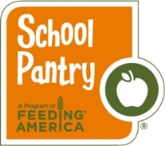

Dear Parents & Guardians:

______________________ (name of school) will be offering a School Pantry Program to help meet the nutritional needs of our students and your child has been invited to participate. Listed below is some information on this program, with the option to opt-out of participation:

- There is no cost for this program.

- The School Pantry Program will provide your child with nutritious, easy to prepare foods that they can eat at home during weekends and school holidays. This support is also available for student’s siblings regardless of their enrollment status in school.

- The program is scheduled to begin _____________ (start date) and will continue to operate throughout the school year.

- The food will be distributed at school, by school personnel, at the following times/days: ____________________________________________ (pantry schedule, if applicable add times when pantry is open to family members/community as well.)

- Distribution will be done in a discreet manner.

- Please be advised that the School Pantry contains some foods that may have allergens such as peanuts, nuts, soy, wheat, eggs and milk.

- If you do not want your child to receive supplemental food to take home, please sign and return this form to school:

Parent/Guardian Signature Date

Please help us make informed decisions in our fight against hunger by filling out a short evaluation that will be sent to you at the end of the school year. Your opinion on the program will impact its structure and continuation.

Thank you very much,

(School Pantry coordinator contact info)

