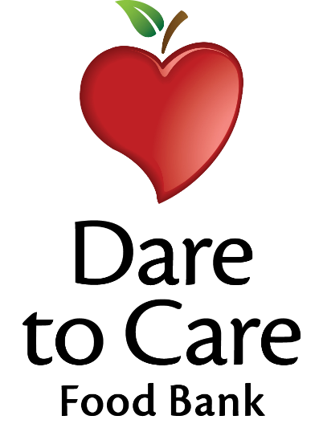

Daily Breakfast Options

WG Assorted Cereal (1 oz.)
Trix, Lucky Charms, Cinnamon Toast Crunch,
Berry Krispies Cereal Bar

WG Assorted Snack (1 oz.)
Mini Cinnamon Grahams, Animal Crackers, Strawberry Bites

100% Fruit Juice (1/2 cup)

Skim Milk (8 fl. oz.)

