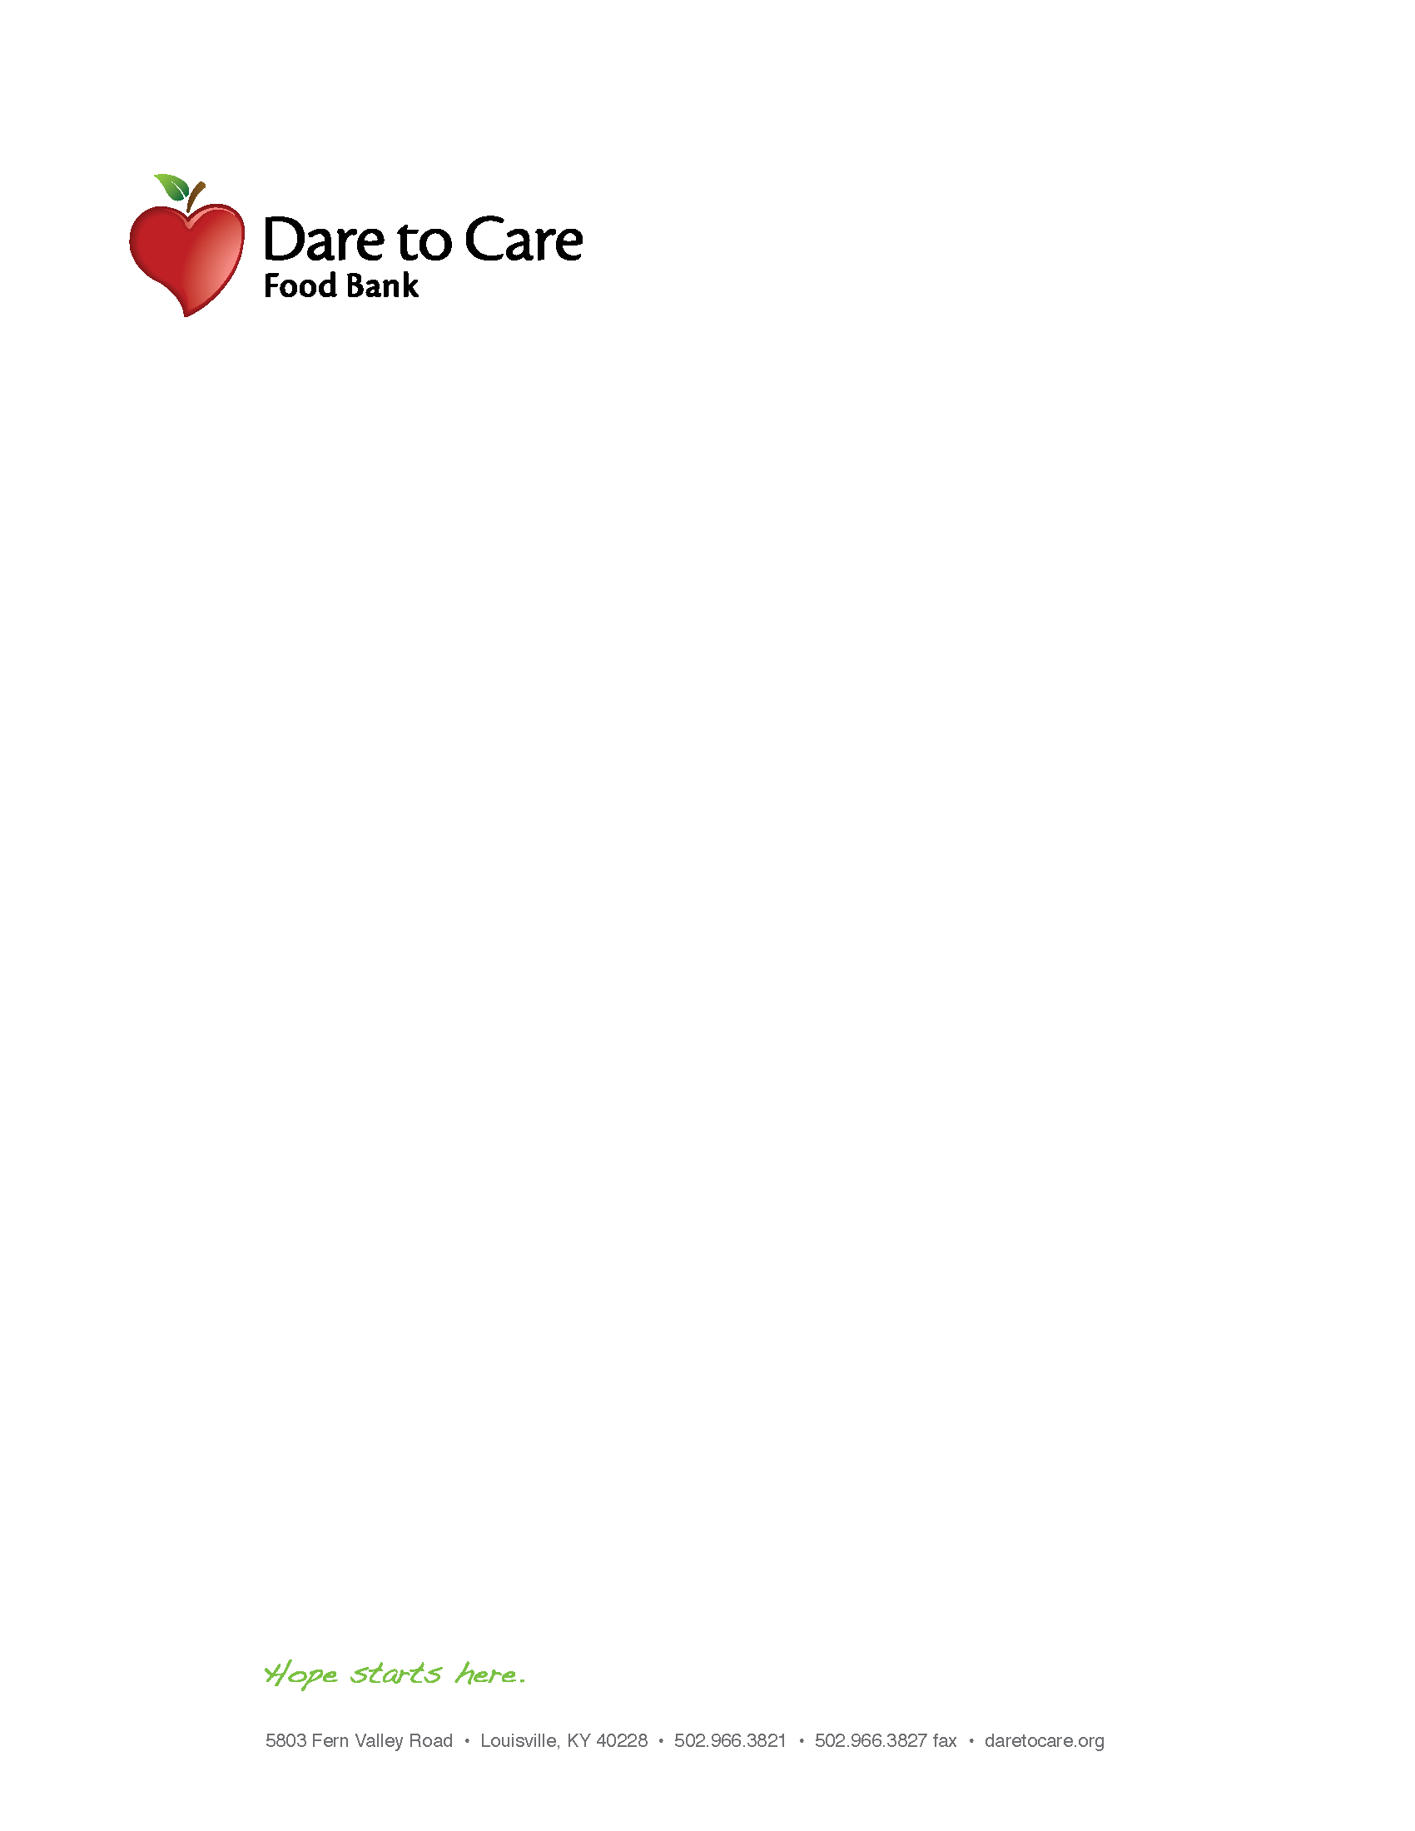

FOOD SAFETY TRAINING PARTNER AGREEMENT

The undersigned agency has completed the Dare to Care Food Safety training and agrees to adhere to all relative policies and regulations set forth by Dare to Care, Feeding America and its respective Health Department.
Date:______________________

I, _____________________________________________________ representing
NAME OF PERSON WHO TOOK TRAINING

______________________________________________________________________________
AGENCY NAME

have participated in the Dare to Care Food Safety training class.

I understand that it is our agency’s responsibility to provide quality products to our clientele in a safe and sanitized environment. I assure that the above precautions will be taken on all products received from Dare to Care Food Bank, including salvage product.

SIGNATURE

QUESTIONS | PRE-TEST ANSWERS | POST-TEST ANSWERS
- What is a foodborne illness?
- What is a foodborne illness outbreak?
- Which three populations are most at risk of a foodborne illness?
- What is the temperature danger zone?
- How often should temperatures be checked and recorded?
- What is the most effective way to prevent foodborne illness?
- How long should temperature recording sheets be kept on-site, and on-file?
- What do pathogens need to grow and multiply?
- What are the three types of contamination?
- In what order should dry goods, frozen foods, and refrigerated foods be put away?
- What is the best defense against foodborne illness?
- Thermometers should be kept in every freezer, every refrigerator, and every dry stock area? True or False

