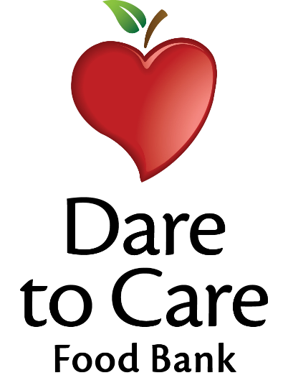

Daily Breakfast Options

WG Assorted Cereal (1 oz.)
Lucky Charms, Cinnamon Toast Crunch,
Fruit Loops

WG Assorted Snack (1 oz.)
Mini Cinnamon Grahams, Animal Crackers, Strawberry Bites

100% Fruit Juice (1/2 cup)

Skim Milk (8 fl. oz.)

