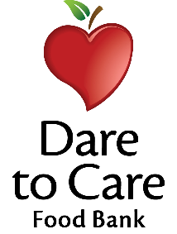

GRAB and GO Menu

Grilled Chicken Nuggets - 2.6oz
WG Goldfish Crackers – 1 package
Pineapple Fruit Cup – 4 oz.
Suncup 100% Juice – 4 fl. oz
Skim Milk – 8 fl. oz.

Roast Turkey and Cheese Sandwich – 3 oz
Wheat Bun – 1 each
WG Cheezit Crackers – 1 package
Mandarin Orange Fruit Cup – 4 oz.
Suncup 100% Juice – 4 fl. oz
Skim Milk – 8 fl. oz.

Mini Corndogs – 4 each
WG Goldfish Crackers – 1 package
Apple – 1 each
Suncup 100% Juice – 4 fl. oz
Skim Milk – 8 fl. oz.

Chicken Quesadilla – 1 each
WG Cheezit Crackers – 1 package
Apple – 1 each
Suncup 100% Juice – 4 fl. oz
Skim Milk – 8 fl. oz.

Pizza/Turkey Lunchables – 1 each
WG Pretzels – 1 package
Mandarin Orange Fruit Cup – 4 oz.
Suncup 100% Juice – 4 fl. oz
Skim Milk – 8 fl. oz.

