Plated Meals

Monday

Tuesday

Wednesday

Thursday
Ages: 6-18

Friday

30  Boneless Chicken Wings – 3 oz.  WG Roll – 1 each  Celery w/ Ranch – ½ c. (FR)  100% Juice – 1 each  Skim Milk – 8 fl. oz. | 1  WG Mini Pancakes w/ Turkey Sausage – 6 each  Baby Carrots w/ Ranch – ½ c. (FR)  100% Juice – 1 each  Skim Milk - 8 fl. oz. | 2  WG Mini Corndogs – 4 each  3 Bean Salad – ½ cup  100% Juice – 1 each  Skim Milk - 8 fl. oz. | 3  WG Chicken Eggroll – 3 oz.  Broccoli w/ Ranch – ½ c. (FR)  100% Juice – 1 each  Skim Milk - 8 fl. oz. | 4  Turkey Sausage Pizza – 2 each  Coleslaw – 1/2 cup  100% Juice – 1 each  Skim Milk - 8 fl. oz.
7  WG Soft Pretzel – 1 oz.  Cheese Cup – 4 oz.  Broccoli w/Ranch – 1/2 cup (FR)  Nectarine/Fruit cup – 1 each or ½ cup (FR/CN)  Skim Milk – 8 fl. Oz. | 8  Enriched Pita Chips – 1.5 oz.  Hummus – 2 oz.  Baby Carrots w/ Ranch – ½ c. (FR)  Apple/Applesauce – 1 each or ½ cup (FR/CN)  Skim Milk—8 fl. oz. | 9  Granola Bar – .84 oz.  Yogurt – 4 oz.  Celery w/ Ranch – ½ c. (FR)  Banana—1 each  Skim Milk—8 fl. oz. | 10  Bagel – 1 oz.  Cream Cheese—4 oz.  !00% Veggie Juice—4 fl. oz.  Clementine – 1 each  Skim Milk—8 fl. oz. | 11  Lunchable  Turkey & Cheese—2 oz.  WG Crackers—1 oz.  100% Veggie Juice – 4 fl. oz.  Fruit Cup—1/2 cup (CN)  Skim Milk—8 fl. oz.
14  String Cheese – 2 oz.  WG Graham Crackers – 1 each  Baby Carrots w/ Ranch – ½ c. (FR)  Plum/Fruit cup – 1 each or ½ cup (FR/CN)  Skim Milk—8 fl. oz. | 15  WG Tortilla Chips – 1 oz.  Nacho Cheese Cup – 4 oz.  Broccoli Salad – ½ c. (FR)  Grapes- ½ cup (FR)  Skim Milk—8 fl. oz. | 16  Uncrustable  Soybutter – 2 oz.  WG Bread – 1 each  Celery w/ Ranch – ½ c. (FR)  Banana – 1 each  Skim Milk – 8 fl. Oz. | 17 Cereal Bar – 1 oz. Yogurt – 4 oz. Celery w/ Ranch – ½ c. (FR) Apple/Applesauce – 1 each or ½ cup (FR/CN) Skim Milk—8 fl. oz. 6 Meatball Sub—2 oz. WG Bun—1 each Broccoli & Cheese—1/2 cup (FZ) Pineapple – 4 oz. (FR) Skim Milk—8 fl. oz. | 18 Lunchable Pepperoni/Cheese—2 oz. WG Crust—1 oz. 100% Veggie Juice – 4 fl. oz. Fruit Cup—1/2 cup (CN) Skim Milk—8 fl. oz. 6 Meatball Sub—2 oz. WG Bun—1 each Broccoli & Cheese—1/2 cup (FZ) Pineapple – 4 oz. (FR) Skim Milk—8 fl. oz.
21  WG Soft Pretzel – 1 oz.  Cheese Cup – 4 oz.  Broccoli w/Ranch – 1/2 cup (FR)  Nectarine/Fruit cup – 1 each or ½ cup (FR/CN)  Skim Milk – 8 fl. Oz. | 22  WG Pita Chips – 1.5 oz.  Hummus – 2 oz.  Baby Carrots w/ Ranch – ½ c. (FR)  Apple/Applesauce – 1 each or ½ cup (FR/CN)  Skim Milk—8 fl. oz. | 23  Granola Bar – 1 oz.  Yogurt – 4 oz.  Celery w/ Ranch – ½ c. (FR)  Banana—1 each  Skim Milk—8 fl. oz. | 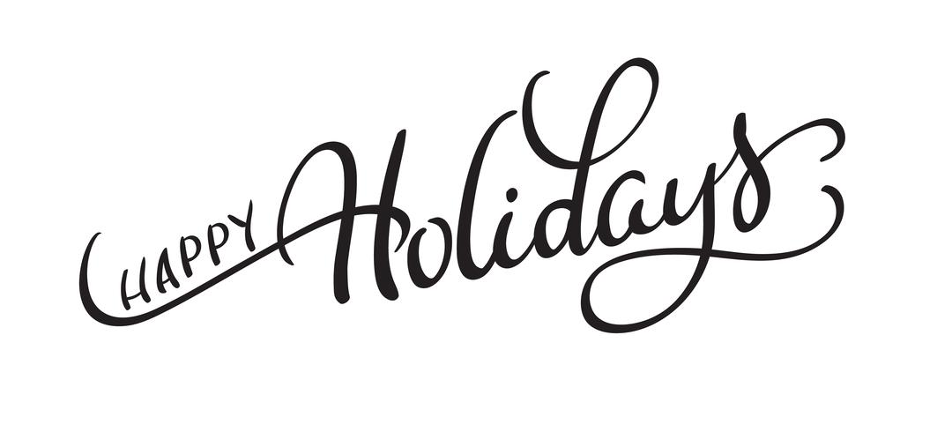
28  String Cheese – 2 oz.  WG Graham Crackers – 1 each  Baby Carrots w/ Ranch – ½ c. (FR)  Plum/Fruit cup – 1 each or ½ cup (FR/CN)  Skim Milk—8 fl. oz. | 29  WG Tortilla Chips – 1 oz.  Nacho Cheese Cup – 4 oz.  Broccoli Salad – ½ c. (FR)  Grapes- ½ cup (FR)  Skim Milk—8 fl. oz. | 30  Uncrustable  Soybutter – 2 oz.  WG Bread – 1 each  Celery w/ Ranch – ½ c. (FR)  Banana – 1 each  Skim Milk – 8 fl. Oz.

