Plated Meals

Monday

Tuesday

Wednesday

Thursday
Ages: 6-18

Friday

30  Turkey BLT – 3 oz.  WG Bun – 1 each  Roasted Corn Salad – ½ cup (CN)  100% Juice – 1 each  Skim Milk – 8 fl. oz. | 1  Grilled Chicken Nuggets –  WG Mac N Cheese – 3 oz.  Broccoli – ½ cup (FZ)  100% Juice – 1 each  Skim Milk - 8 fl. oz. | 2  Asian Chicken Salad  Chicken Strips– 3 oz.  Garden Salad – ½ cup  WG Goldfish Crackers – 1 oz.  100% Juice – 1 each  Skim Milk - 8 fl. oz. | 3  Beef N Cheese Nachos – 3 oz.  WG Tortilla Chips – 1 oz.  Fiesta Corn – ½ cup  100% Juice – 1 each  Skim Milk - 8 fl. oz. | 4  Turkey & Cheese Sandwich  Turkey & Cheese – 3 oz.  WG Bun – 1 each  Garden Salad – ½ cup  100% Juice – 1 each  Skim Milk - 8 fl. oz.
7  Chicken Queso.  Tortilla Chips – 1 oz.  Banana Peppers – 1/2 cup (CN)  Apple/Applesauce – 1 each (FR/CN)  Skim Milk – 8 fl. Oz. | 8  Chili – 3 oz.  WG Crackers – 3 oz.  Broccoli & Cheese – ½ c. (FZ)  Nectarine– 1 each (FR)  Skim Milk—8 fl. oz. | 9  Mac N Cheese  Cheese – 4 oz.  WG Macaroni – 2 oz.  WG Bun—1 each  Potato Wedges—1/2 cup (FR)  Green Beans –1/2 cup (FZ)  Skim Milk—8 fl. oz. | 10  Fried Chicken—3 oz.  WG Roll—1 each  Mashed Potatoes w/ Gravy – ½ cup (FR)  Carrot Coins—1/2 cup (FR)  Skim Milk—8 fl. oz. | 11  Hamburger—2 oz.  WG Hamburger Bun—1 each  Home Fries— ½ c (FR)  Grapes—1/2 cup (FR)  Skim Milk—8 fl. oz.
14  Turkey Hot Dog – 2 oz.  WG Wheat Bun – 1 each  Home Fries – ½ cup (FR)  Grapes – ½ cup (FR)  Skim Milk—8 fl. oz. | 15  Chicken Parmesan – 2 oz.  WG Penne Pasta – ½ cup  Twisted Garlic Bread Roll – 1 each  Carrots – ½ cup (FZ)  Apple/Applesauce – 1 each (FR/CN)  Skim Milk – 8 fl. Oz | 16  Meatloaf – 3 oz.  WG Roll – 1 each  Mashed Potatoes w/ Gravy –  ½ cup (FR)  Green Beans – ½ Cup (FZ)  Skim Milk – 8 fl. Oz. | 17 Chicken Fried Rice Chicken - 2 oz. WG Fried Rice—1 oz. Veggie Blend – ½ cup (FZ) Banana – 1 each (FR) Skim Milk—8 fl. oz. 6 Meatball Sub—2 oz. WG Bun—1 each Broccoli & Cheese—1/2 cup (FZ) Pineapple – 4 oz. (FR) Skim Milk—8 fl. oz. | 18 Smothered Chicken—2 oz. Skillet Cabbage – ½ cup (FR) Sweet Potato Casserole – ½ cup (FR) Skim Milk—8 fl. oz. 6 Meatball Sub—2 oz. WG Bun—1 each Broccoli & Cheese—1/2 cup (FZ) Pineapple – 4 oz. (FR) Skim Milk—8 fl. oz.
21  Chicken Queso.  Tortilla Chips – 1 oz.  Banana Peppers – 1/2 cup (CN)  Apple/Applesauce – 1 each (FR/CN)  Skim Milk – 8 fl. Oz. | 22  Chili – 3 oz.  WG Crackers – 3 oz.  Broccoli & Cheese – ½ c. (FZ)  Nectarine– 1 each (FR)  Skim Milk—8 fl. oz. | 23  Mac N Cheese  Cheese – 4 oz.  WG Macaroni – 2 oz.  WG Bun—1 each  Potato Wedges—1/2 cup (FR)  Green Beans –1/2 cup (FZ)  Skim Milk—8 fl. oz. | 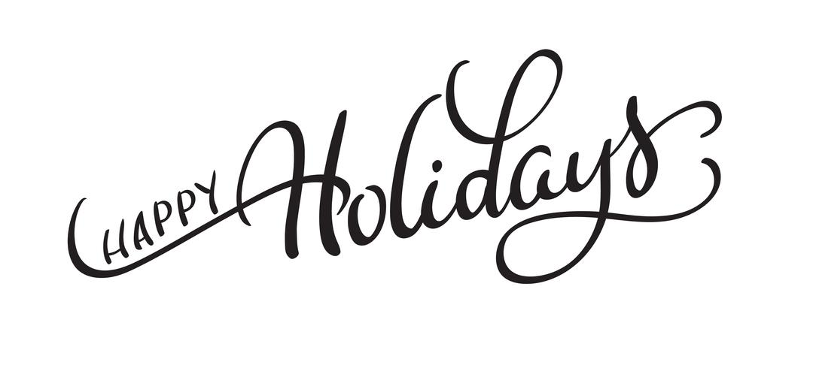
28  Turkey Hot Dog – 2 oz.  WG Wheat Bun – 1 each  Home Fries – ½ cup (FR)  Grapes – ½ cup (FR)  Skim Milk—8 fl. oz. | 29  Chicken Parmesan – 2 oz.  WG Penne Pasta – ½ cup  Twisted Garlic Bread Roll – 1 each  Carrots – ½ cup (FZ)  Apple/Applesauce – 1 each (FR/CN)  Skim Milk – 8 fl. Oz | 30  Meatloaf – 3 oz.  WG Roll – 1 each  Mashed Potatoes w/ Gravy –  ½ cup (FR)  Green Beans – ½ Cup (FZ)  Skim Milk – 8 fl. Oz.

