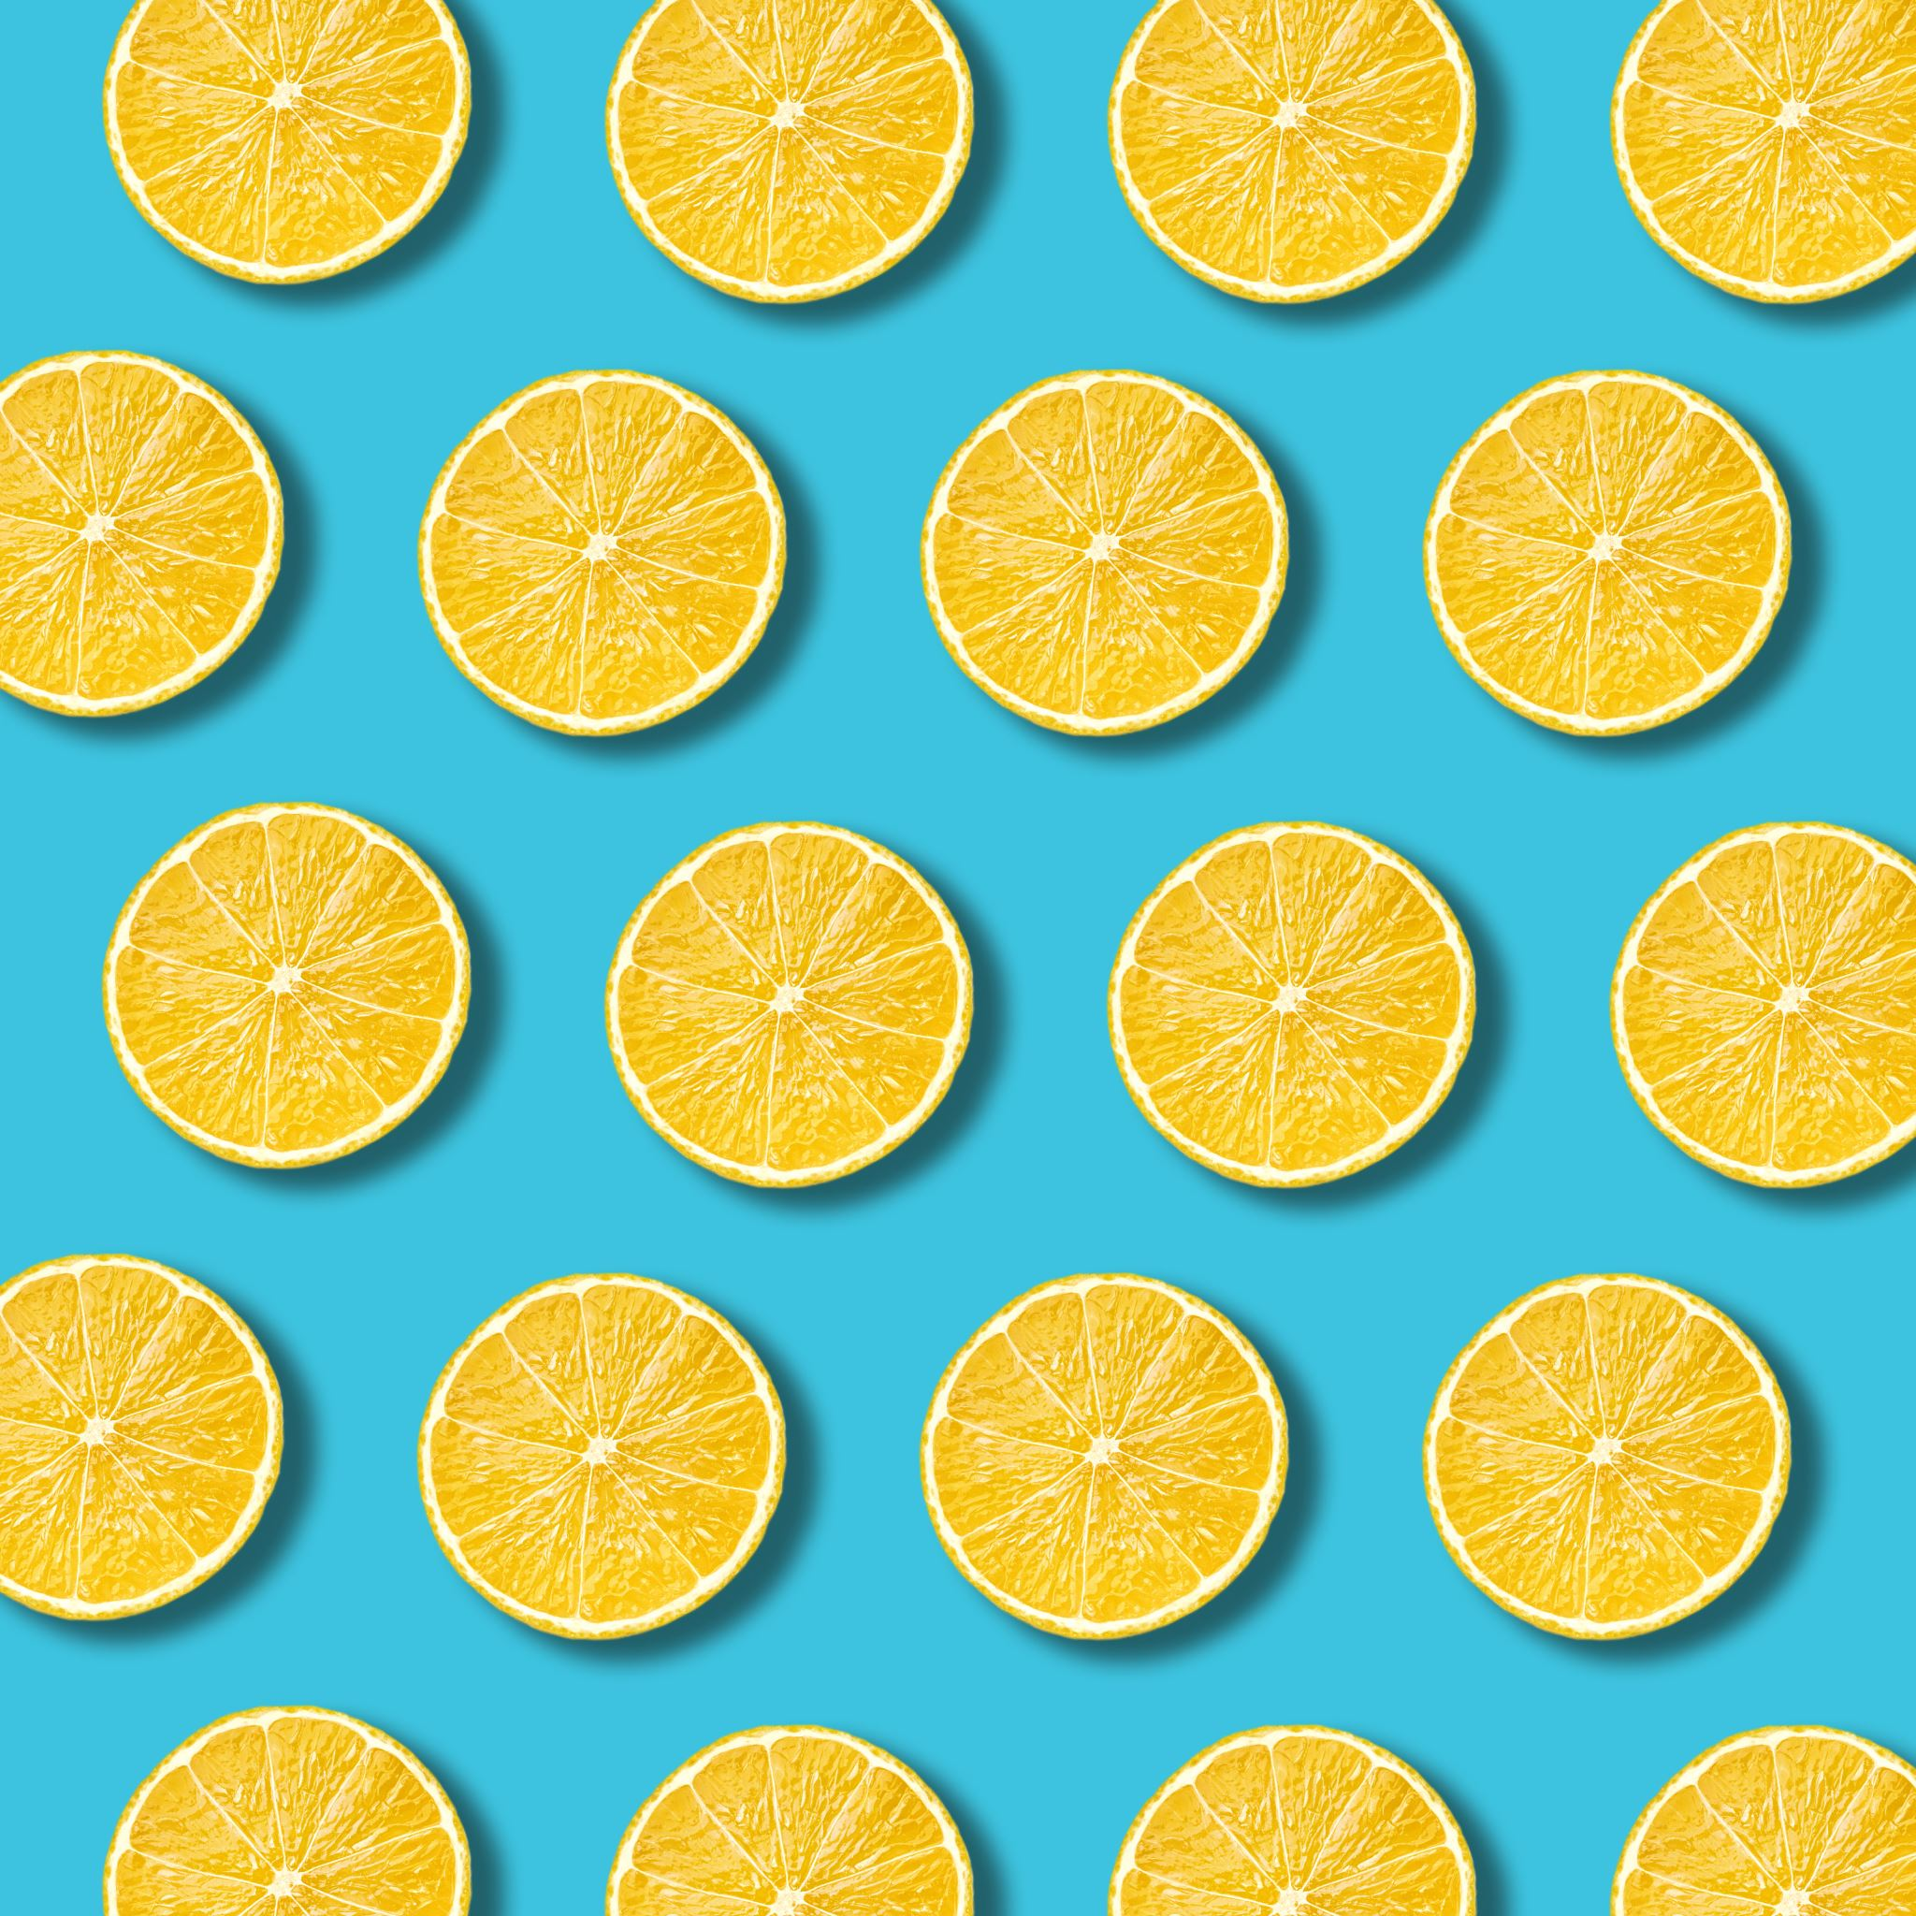
PM Snack

Monday

Tuesday

Wednesday

Thursday
Ages: 6-18

Friday

Beef N Bean Burrito  Fresh Apple  Juice  1x Mild Taco Sauce Packet | Cheese Cup  WG Pretzel  Fresh Nectarine  Juice | String Cheese x 2  WG Graham Crackers  Fresh Plum  Juice | Grilled Chicken Sandwich  WG Bun  Fresh Clementine  Juice  1x BBQ Sauce Packet | Shelf Stable Lunch Kit – Variety
Chicken Taquitos x 2  Fresh Clementine  Juice  1x Milk Taco Sauce Packet | Yogurt  Granola Bar x 2  Fresh Plum  Juice | Soybutter Uncrustable  WG Cheez-It  Fresh Apple  Juice | Turkey & Cheese Sandwich WG Bun Fresh Nectarine Juice 6 Meatball Sub—2 oz. WG Bun—1 each Broccoli & Cheese—1/2 cup (FZ) Pineapple – 4 oz. (FR) Skim Milk—8 fl. oz. | Shelf Stable Lunch Kit – Variety 6 Meatball Sub—2 oz. WG Bun—1 each Broccoli & Cheese—1/2 cup (FZ) Pineapple – 4 oz. (FR) Skim Milk—8 fl. oz.

