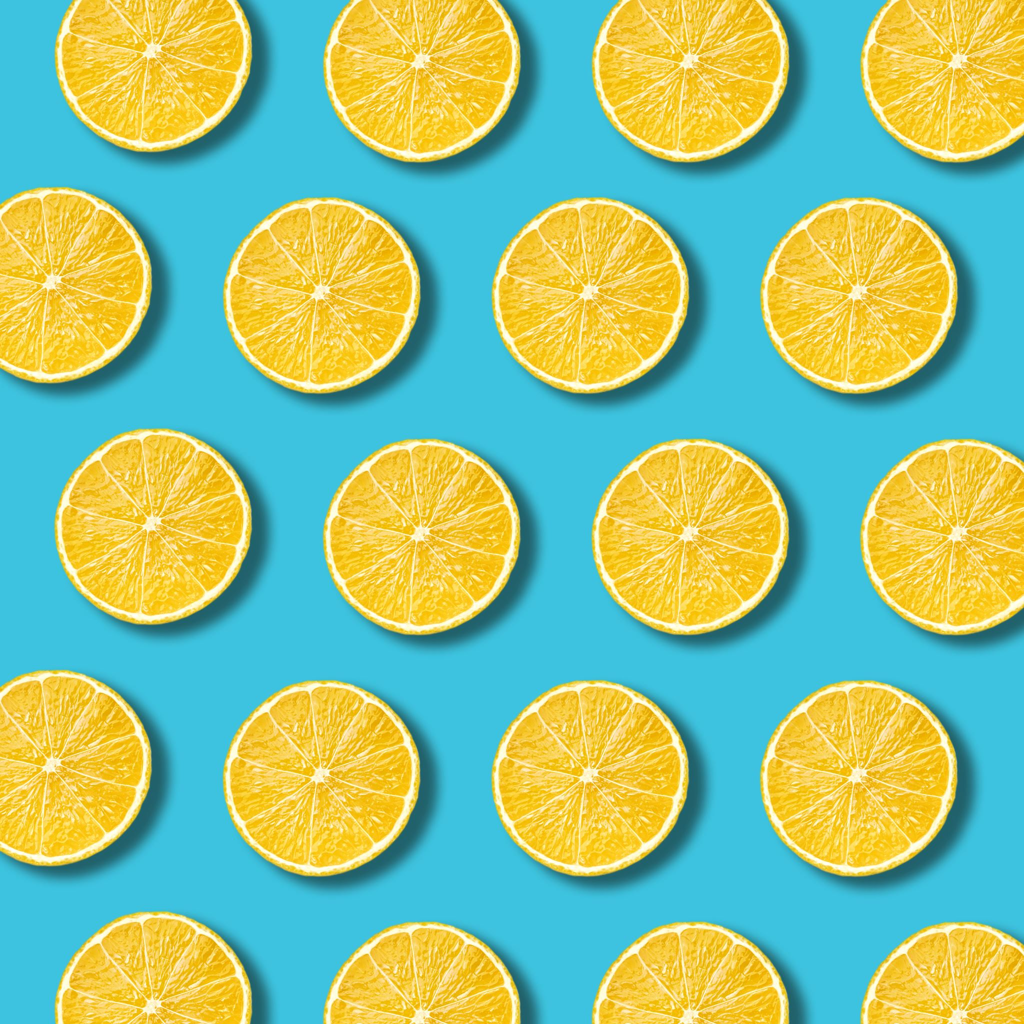
PM Snack

Monday

Tuesday

Wednesday

Thursday
Ages: 6-18

Friday

Mini corndogs x 4  Fresh Apple  Juice  1x ketchup | Cheese Cup  WG Pretzel  Fresh Nectarine  Juice | String Cheese x 2  WG Graham Crackers  Fresh Plum  Juice | Grilled Chicken Sandwich  WG Bun  Fresh Clementine  Juice  1x BBQ Sauce Packet | WG Bagel  Fresh Grapes  Juice  1x Cream Cheese
Mini pancake wraps  Fresh Clementine  Juice  1x syrup cup | Yogurt  Granola Bar x 2  Fresh Plum  Juice | Soybutter Uncrustable  WG Cheez-It  Fresh Apple  Juice | Turkey & Cheese Sandwich WG Bun Fresh Nectarine Juice 6 Meatball Sub—2 oz. WG Bun—1 each Broccoli & Cheese—1/2 cup (FZ) Pineapple – 4 oz. (FR) Skim Milk—8 fl. oz. | Hummus Cup WG Pretzel Juice 6 Meatball Sub—2 oz. WG Bun—1 each Broccoli & Cheese—1/2 cup (FZ) Pineapple – 4 oz. (FR) Skim Milk—8 fl. oz.

