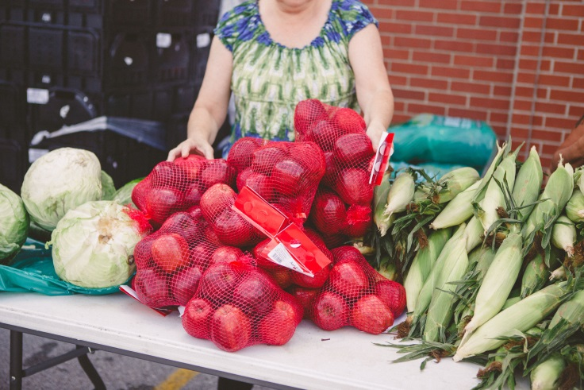

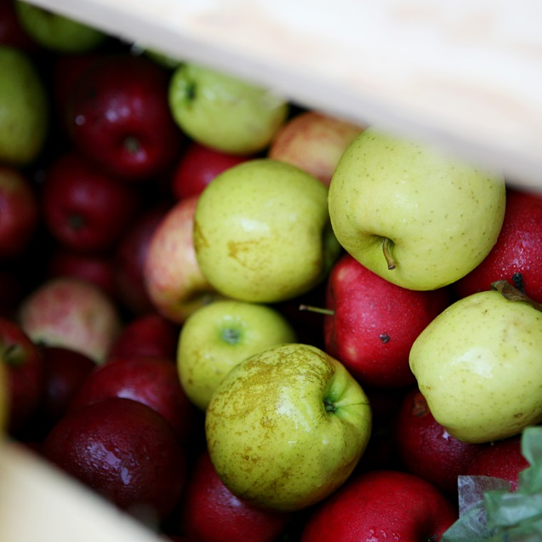

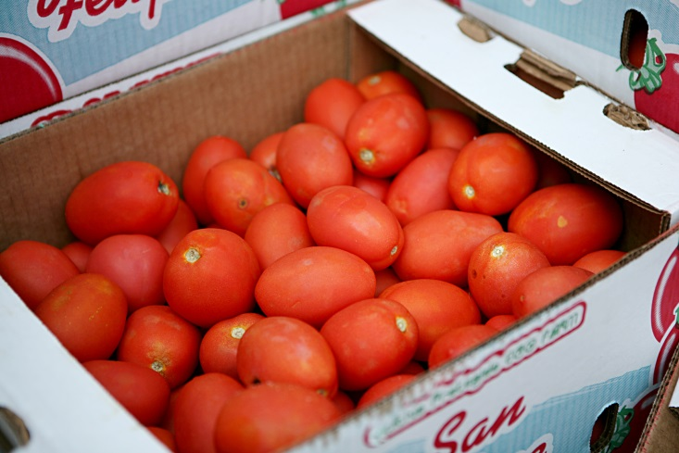

PARTNER AGENCY HANDBOOK
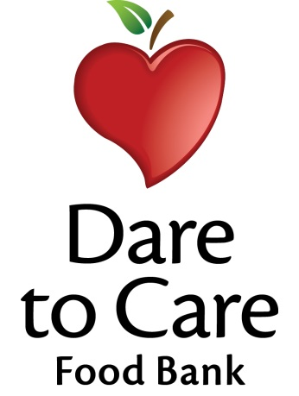
The Dare to Care Food Bank (DTC) Partner Agency Handbook was designed to provide our partner agencies with the information, tools and knowledge needed to be a successful food bank partner. This handbook outlines how best to utilize the partner development staff, as well as tips, tricks and guidelines to running a program. It also details various policies enforced by Dare to Care, USDA and Feeding America.
As a member of the Feeding America Network, Dare to Care is held accountable to follow a set of standards and procedures set forth by Feeding America, USDA, and the IRS. Therefore, Dare to Care expects all of its partner agencies and programs to adhere to those same policies and standards.
The Partner Agency Handbook serves as a reference to address any questions that may arise within a partnership with Dare to Care. This guide is meant to help agencies understand the procedures and policies set forth by the foodbank.

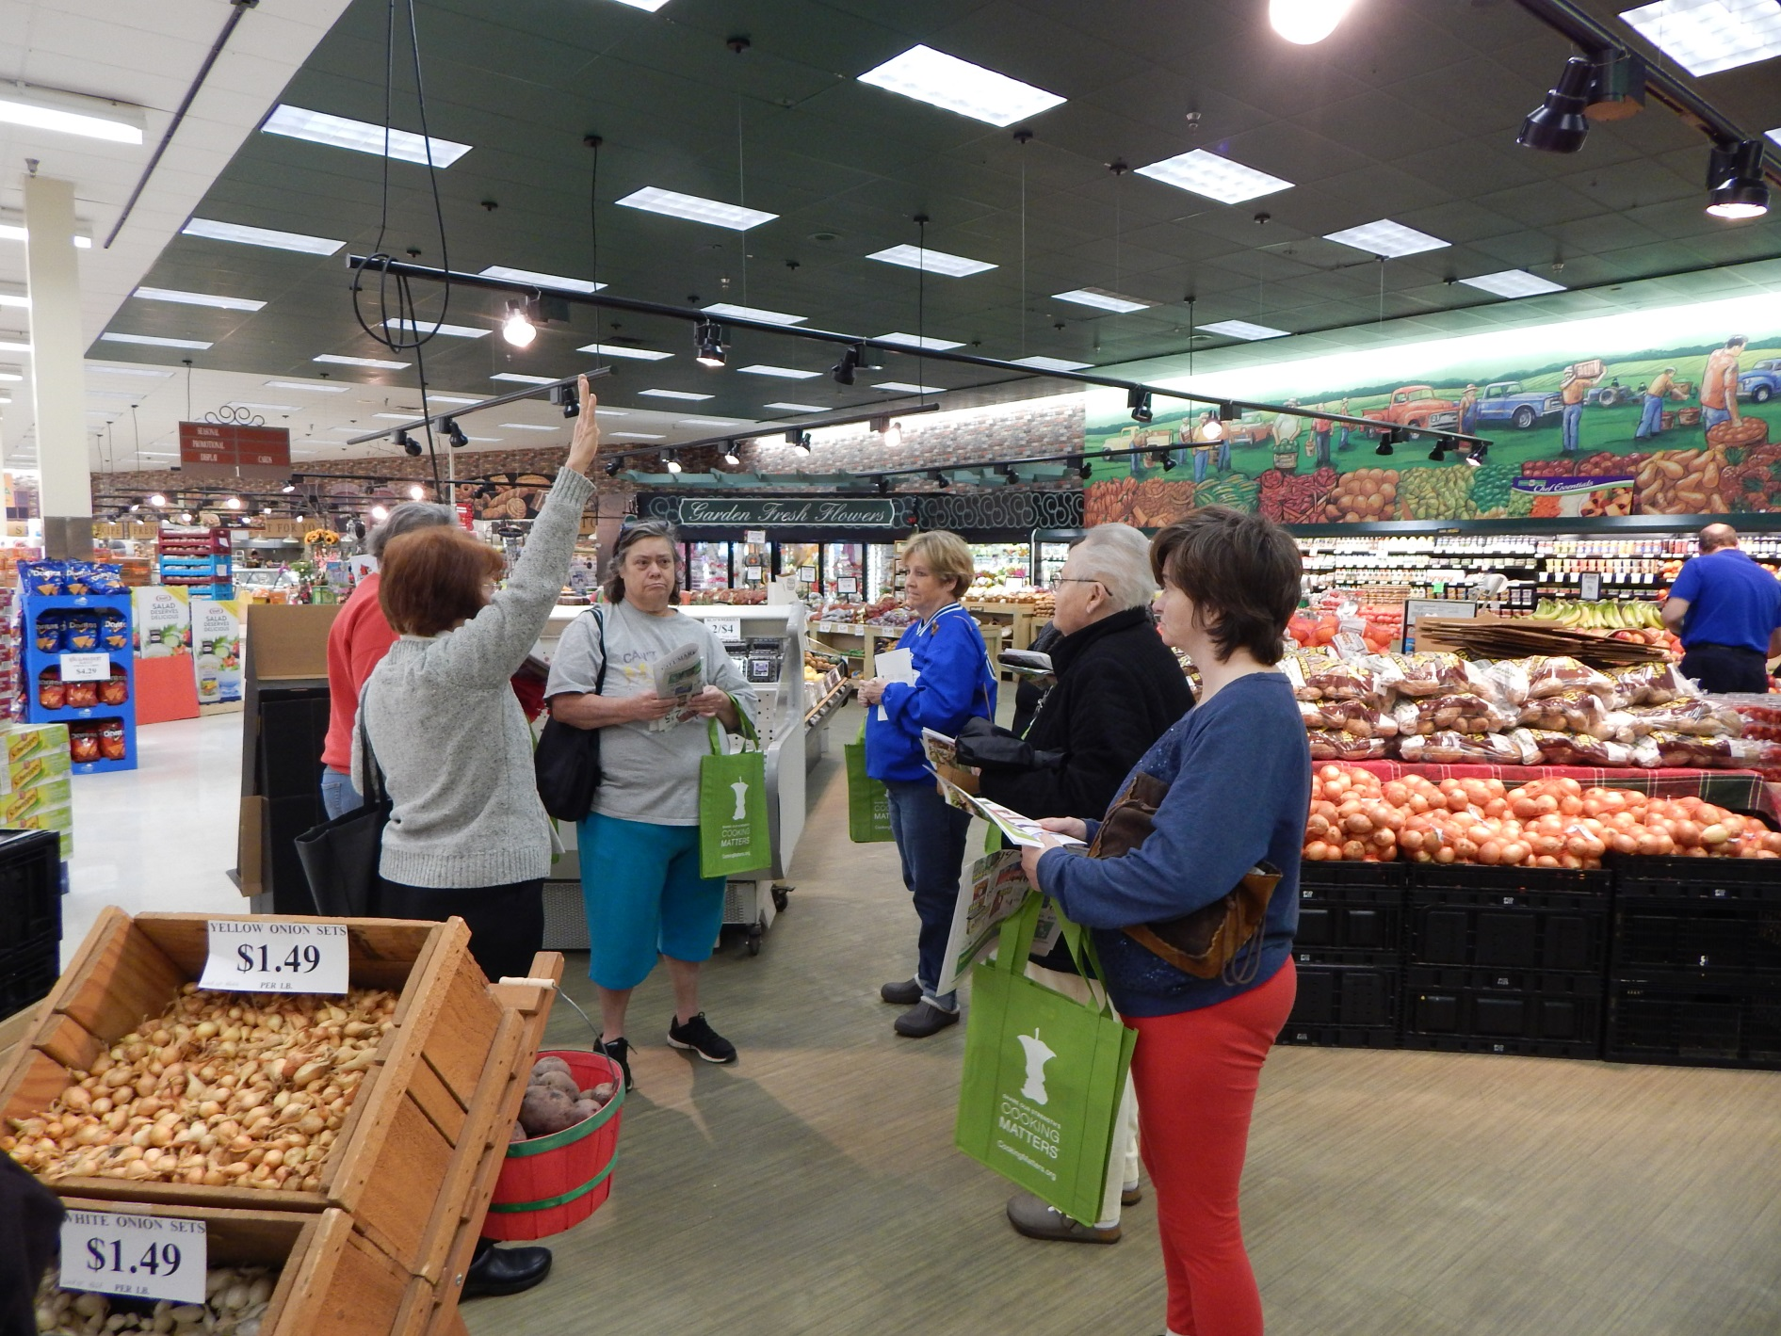

WELCOME

Dear Dare to Care Partners,
Welcome to the Dare to Care Food Bank! Thank you for your dedicated partnership to help us conquer the cycle of need in Kentuckiana. In 2021, Dare to Care distributed 21.7 million meals to individuals facing food insecurity in our community.
All of this could not have been accomplished without the help of you, our partner agencies. Because of you, we are reaching more families and ensuring they have the healthy food and nourishment they need. We deeply appreciate your dedication to this mission and helping individuals in our community thrive. Here’s to continuing these great efforts together into the future!
Sincerely,
Vincent James
Executive Director

ABOUT DARE TO CARE

Dare to Care Food Bank was founded in 1971, when a stunned Louisville community was confronted with the horrifying news that right in their own city, on Thanksgiving Day, a nine-year-old boy had died of starvation. The name Dare to Care became the rallying cry of people throughout the area as they joined together to attack the very real problem of hunger in many of their neighborhoods.
Dare to Care receives its food from several sources including manufacturers, USDA commodities, processors, growers, retailers, wholesalers, distributors and consumers (those who donate product to food drives/ Care Barrels/ churches/ schools/ businesses). The vast majority of our food is donated; therefore, the product available is always changing.

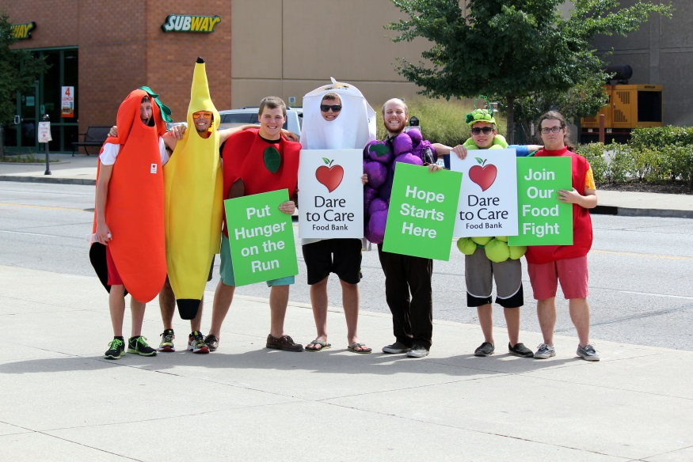
The food bank has a 55,000 square foot warehouse, including a 100,000 cubic foot freezer and 66,000 cubic foot cooler. We have ten transport trucks, 7 of which are refrigerated.

Over 3K volunteers support our mission each year, contributing over 22,000 hours.

YUM! Brands is our largest donor; their donation allows us to be the only food bank in the nation which provides food free of a shared maintenance fee.

VISION
A HUNGER-FREE KENTUCKIANA
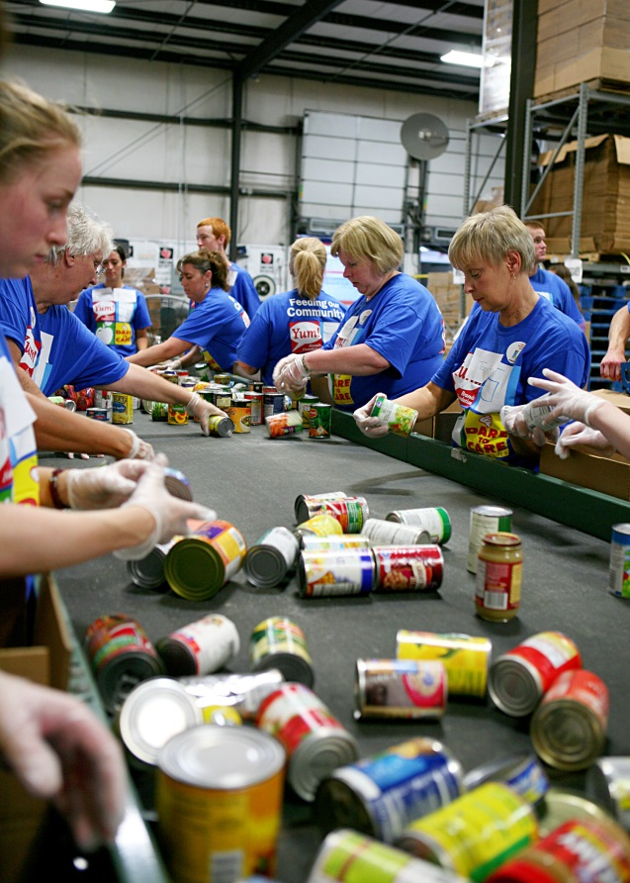

MISSION
TO LEAD OUR COMMUNITY TO FEED THE HUNGRY AND CONQUER THE CYCLE OF NEED

- Dare to Care Food Bank works in partnership with more than 300 nonprofit organizations with approved feeding programs.

- Each year, Dare to Care Kids Cafes serve more than 96,000 meals to children in Kentuckiana.

- Dare to Care Food Bank distributes more than 18 million pounds of food annually.

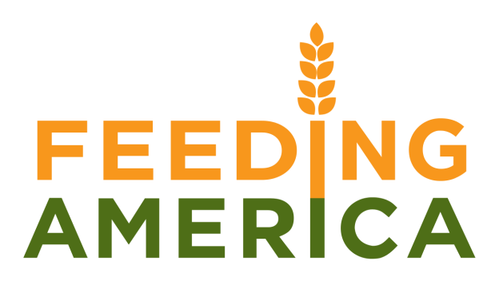

Feeding America is the nation’s largest non-governmental feeding program. Incorporated in Phoenix, Arizona in 1979, Feeding America has grown from a few volunteers distributing food to a handful of local non-profit organizations, to a national network of more than 200 food banks in all fifty states.
Dare to Care Food Bank became a member of Feeding America in 1983. In order to maintain membership with this organization, Dare to Care Food Bank must maintain high standards of accountability in food handling. Our organization has received consistent high ratings on monitoring visits by regional officials. In addition, Dare to Care Food Bank is also subject to similar annual inspections by the food industry.
The mission of the Dare to Care Food Bank Program is to make every effort, on both the national and local levels, to rescue approximately 20% of the food America wastes between field and table.

Kentucky Association of Food Banks (KAFB) is a 501(c)3 charitable organization working to end hunger in Kentucky. KAFB’s seven member food banks serve all 120 Kentucky counties in partnership with a network of over 1,000 local food pantries and shelters. Last year our members distributed 60.5 million pounds of food and grocery products — enough for 50,400,000 meals for our struggling neighbors. We reach an estimated 1 in 7 of all Kentuckians each year.

HOURS OF OPERATION

FOOD BANK HOURS OF OPERATION
Dare to Care is open Monday – Friday, 8:00 AM – 4:00 PM
Front Desk: 502-966-3821
AGENCY SERVICE HOURS (DOCK HOURS)
Monday – Thursday: 7:30 AM – 1:30 PM
Friday: 7:30 AM – 12:00 PM
DARE TO CARE HOLIDAY SCHEDULE
The Food Bank will be closed on the following holidays:
- New Year’s Day
- Martin Luther King Jr. Day
- Memorial Day
- Independence Day
- Labor Day
- Thanksgiving Day & the following Friday
- Christmas Eve & Christmas Day

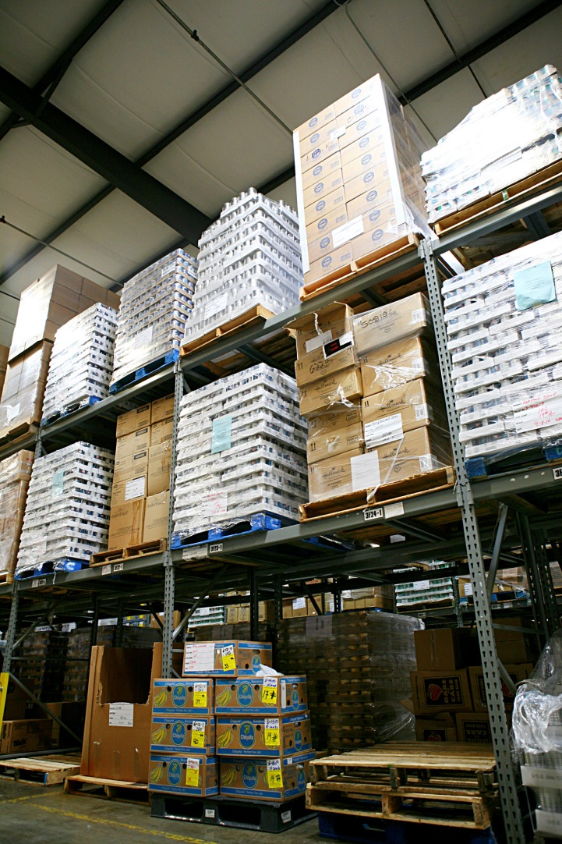

INVENTORY
Dare to Care conducts an annual, week-long audit of the warehouse inventory at the end of the fiscal year. This takes place at the end of June each year.
During inventory week, ordering is suspended, and no orders are available for pick-up at the dock.
The date of inventory week is announced in April of each year. Additional information relating to warehouse closings and delivery changes will be communicated via email and posted on the Dare to Care website.

INCLEMENT WEATHER POLICY?
As a rule, the Dare to Care warehouse makes every effort to remain open during inclement weather. Our trucks are pulled from the road when snow or ice creates unsafe conditions.

Dare to Care’s Partner Agencies set their own inclement weather policies. Please see the Dare to Care website for updated information.

DTC STAFF & RESOURCES

PARTNER DEVELOPMENT TEAM:
Trish Tobbe, Partner Development Team Representative:
(502) 736-9918, trish.tobbe@daretocare.org
Clifton Griffin, Ph.D, Partner Team Development Representative:
(502) 736-9915, clifton.griffin@daretocare.org
DARE TO CARE INFORMATION:
Address: 5803 Fern Valley Road,
Louisville, KY 40228
Main Line: (502) 966-3821
Fax: (502) 966-9252
Additional Contacts:
David Schlosser, Chief Operations Officer:
(502) 736-9411, David@daretocare.org
Vincent James, Executive Director:
(502) 736-9409 vincent.james@daretocare.org
HELPFUL RESOURCES:
- Dare to Care Website: www.daretocare.org
- Utilities Assistance: Metro United Way Resource Line 211
- Food Stamp Application Assistance: http://www.louisvilleky.gov/NeighborhoodPlace

Dare to Care Food Bank reaches individuals facing hunger through our network of over 300 dedicated partner agencies that are committed to ending hunger in Kentuckiana. Through our strong network of partner agencies, Dare to Care has been able to distribute over 18 million pounds of food to families in need.
PARTNER AGENCIES

Partner agencies include food pantries, shelters, emergency kitchens and other organizations in our community. Dare to Care donates food from our inventory to these agencies. In turn, these agencies are on the front lines, directly providing food assistance to community members in need.
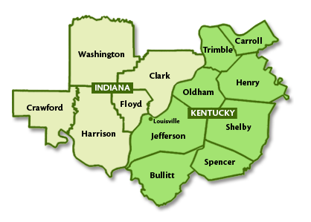
OUR SERVICE AREA

Dare to Care serves the Metro Louisville area, including Jefferson, Bullitt, Spencer, Shelby, Henry, Oldham, Trimble, and Carroll; and the following Indiana counties: Floyd, Clark, Harrison, Crawford and Washington.

HOW WE WORK

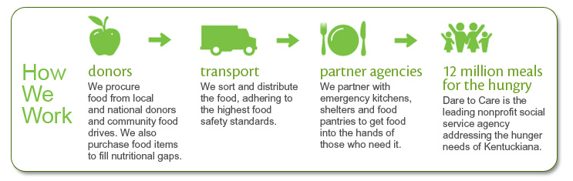

In addition to providing food to hundreds of emergency kitchens, shelters and food pantries, Dare to Care operates several programs targeting the most vulnerable in our community.
PROGRAMS & EVENTS
PROGRAMS:
Backpack Buddy: provides nutritious, kid-friendly foods to children from low-income families on weekends when they do not receive free and reduced-price breakfasts and lunches.
Community Kitchen: prepares and delivers hot, nutritious meals to Kids Cafes.
Mobile Pantry: brings a pantry directly to a neighborhood and provides fresh produce and other nutritious food items for our neighbors in isolated pockets of need.
Patrol Against Hunger: provides nutritionally balanced food boxes to seniors in need through a unique partnership with the Louisville Metro Police Department.
Cooking Matters: empowers families with the skills, knowledge and confidence to prepare healthy and affordable meals.
ANNUAL EVENTS:
Bobby Ellis Vigil: Each year we honor the life of Bobby Ellis, the 9 year old boy who died of malnutrition on Thanksgiving Eve in 1969. Bobby’s tragic death spurred community action and formed Dare to Care to make sure what happened to Bobby never happens again.
Taste of Derby: Presented by Brown- Forman, Louisville’s favorite annual restaurant tasting event includes delicious samples from over 60 celebrated local restaurants, bourbon distilleries and beverage companies. Enjoy our Bloody Mary contest, silent auction and more!
The Hunger Walk: A 5K Walk and Run, presented by Aramark, benefiting Dare to Care Food Bank. Over 2,000 people put hunger on the run and make a public commitment that everyone will have access to the food they need to be healthy.
CANstruction: A bi-annual design/build competition held at Mall St. Matthews. Teams compete to design and construct amazing works of art using canned goods. The canned goods are then donated to Dare to Care to help feed families in our community.
Our qualified partners provide how Dare to Care Food Bank can get its food where it needs to go in our community. As a member of the Food Bank, all partner agencies are required to safely and efficiently distribute the resources provided by the Food Bank. Dare to Care may change or revise procedures to comply with Feeding America or government policies. Dare to Care is dedicated to communicating those changes with our partners as quickly as possible.
PARTNERSHIP & LIABILITY
GOOD SAMARITAN ACT
The Good Samaritan Act protects citizens, businesses, volunteers and nonprofit organizations that act in good faith to donate, recover and distribute excess food. It limits liability to acts of gross negligence or intentional misconduct and, absent these, donors and others shall not be subject to civil and criminal liability arising from the nature, age, packaging, or condition of the seemingly wholesome food of the apparently fit grocery products received as donations.
FDA ACT
The United States Federal Food, Drug, and Cosmetic Act, is a set of laws passed by Congress in 1938 giving authority to the U.S. Food and Drug Administration (FDA) to oversee the safety of food, drugs, and cosmetics. Dare to Care and its partner agencies must ensure that any donated product adheres to the standards set forth by the Federal Food, Drug and Cosmetics Act and any regulations that follow.
Dare to Care is committed to the health and food safety of the population we serve. Each partner agency will receive food safety and handling training at the beginning of partnership. In this training, Dare to Care will provide agencies with extensive details to safely store and distribute food.
USDA REGULATIONS
USDA provides food products funded through TEFAP. DTC distributes this food through a contract with the KY and IN Departments of Job and Family Services.
The Dare to Care Partnership Agreement clearly states that all partner agencies must agree to and
adhere all USDA regulations and must keep copies of
the USDA contract and intake records.
When each partner agency signs The Partnership Agreement, they consent to procedures and guidelines for distributing food. These processes are set in place by the Feeding America Network, as well as the Kentucky & Indiana State Department. Other policies are left to the discretion of the agency, where a formal process should be created, including regular documentation and clear communication to clients and volunteers.
SERVICE GUIDELINES
DISCRETIONARY SERVICE OPTIONS
It is up to each individual agency to determine the distribution style and format in which they’d like to operate. There is not a strict requirement on how this is determined but maintaining a fair and equitable process for distributing food is encouraged. Agencies are not to deny anyone in their service area. It is recommended that a full presentation of food box be presented to clients one time per month/ per family unit. A family unit is defined as all individuals that reside/ live at or in the same address.
It is a recommendation of Dare to Care that all first-time clients be served upon their initial visit. After that, clients should be referred to their appropriate distribution center. Dare to Care discourages food distribution from its main warehouse. This is because we encourage families to go to the pantries and meal sites nearest them.
It is at the agency’s discretion to determine the type of photo ID and residence form it will accept, if at all. ID’s, proof of address and proof of children (report cards, birth certificates, etc.) are all acceptable means of identification. Social security cards are not. Your distribution should be based on the client’s self-declaration of income. Dare to Care does not require individuals to show proof of income.
Agencies may also offer additional social services resources in addition to your food program if desired. Please refer clients to these local resources when applicable.
We encourage that you communicate all policy changes and closings to the clients in your area and offer them information on the other feeding sites in your area.
- See Agency Agreement for further stipulations, including serving all populations
regardless of race, gender, nationality, etc.

PARTNERSHIP AGREEMENT
Dare to Care Food Bank is a nonprofit corporation with a vision of a hunger-free Kentuckiana and a mission to lead the community to feed the hungry and conquer the cycle of need. Dare to Care executes its mission by partnering with other nonprofit agencies and churches who share a commitment to fight hunger in Kentuckiana.

All partners of the food bank must sign the Partnership Agreement. By entering this agreement, Dare to Care (DTC) and each partner agree to be bound by its terms and to work together for a hunger-free Kentuckiana. The purpose of this agreement is to create a relationship where DTC provides food and grocery products to our partners for distribution to those in need.

This section outlines The Partnership Agreement in detail as it relates to food distribution and program operations.
USAGE OF THE FOOD BANK

30 Day Utilization Agreement: Members must use the food bank program at least once per month to remain an active agency, and no more than once per week. We suggest that products be used within six weeks of its pick up date. If an organization does not utilize Dare to Care at least ten to twelve times in a year, it will be subject to review.

Dock Interactions: Products must be taken in one load so it is necessary that you bring adequate assistance as products will not be left for partial pick up. Dockside staff is advised not to leave the dock and members are advised not to stand on the dock for liability and safety purposes.
- Staff Identification: Picture identification may be required of your pick-up personnel. WE MUST be advised of all personnel changes on your letterhead or via email as they occur.

FOOD RECEIPT & INSPECTION AGREEMENT

All product is accepted as is. Dare to Care and the original donor expressly disclaims any warranties in relation to the donation of this product. There have not been, nor are there at any time, any express warranties in relation to this donation of product. Your organization releases the original donor and Dare to Care Food Bank from any liability resulting from use of product from Dare to Care. Your organization further agrees to indemnify and hold the original donor and Dare to Care free from any and all liabilities, damages, losses, claims and causes or action and suits of law or in equity or any obligation of your organization or any personnel employed by your organization in connection with its storage and use of the donated product.

Product Inspection: All produce received from Dare to Care should be inspected in a timely and proper manner upon delivery. If product is found unfit for human consumption, you must notify Dare to Care immediately so that we may take corrective action.
FOOD SAFETY AND STORAGE

Every partner of Dare to Care is required to become certified in ServSafe Food Safety training or acquire equivalent training. If the partner is a meal site, it should already have a Food Safety Manager certification and will be required to provide a copy for our records. Jefferson County Public health standards and certification are also required.

All food programs are to be housed in a public building, such as a church or other civic organization meeting place. Product is never to be stored in a private home.

Full food safety requirements and procedures can be found on pages 19 - 30 in this Handbook.

MISAPPROPRIATION OF FOOD BANK PRODUCT

The tax Reform Act of 1976 states that product received from Dare to Care Food Bank may not be sold, or exchanged for money, other property, or services. Violations will result in immediate suspension and/or termination from the program.

If necessary, Dare to Care Food Bank will not hesitate to prosecute any person or organization found to be in violation of the law.

All products that come to you from Dare to Care Food Bank are under the jurisdiction of the United States Internal Revenue Service or are direct federal property by virtue of having been donated for charitable use under the provisions of Section 501(c)3 of the IRS Code.

Under this code, the lawful use of such products is your providing them absolutely free of charge to the ill, needy, infants and/or elderly in full compliance with your agreement with Dare to Care Food Bank meaning:

- YOU MAY NOT take any Dare to Care Food Bank product for your personal use.
- YOU MAY NOT “pay” yourself or volunteers with Dare to Care Food Bank product.
- YOU MAY with one and only one exception: in group settings where staff eats along with the clients and/or to create a “family atmosphere,” only then may staff consume donated product.
- YOU MAY NOT use food for church suppers, volunteer/staff appreciation, and other activities not associated with the parameter of your program.

The approved non-profit organization can only use Food Bank products to support the program(s) stated on the original application. Dare to Care products are to be used for the approved program only, and not for other purposes.

We are stressing this issue because Dare to Care Food Bank is dealing in merchandise that may tempt some otherwise honest and law-abiding people to break the law. The penalties for misappropriating donated products are severe: if convicted, offenders may face up to 20 years in prison and fines totaling $20,000. In addition, any abuse of Dare to Care Food Bank product will result in immediate and unconditional expulsion from the Dare to Care Food Bank Program.

CLIENT SERVICES

All food donated by Dare to Care must go toward the use by the agreed upon programs and their parameters. Your organization must be an established non-profit 501(C)3 organization serving a clientele of twenty-five or more persons. Your organization must serve the needy, ill or infants and/or elderly. You must provide product received from Dare to Care Food Bank directly to clients, whether on-site or for home use. All products must be free of charge and may not be attached to any religious service or proselytize.

Client referrals are intended to direct individuals and families to their distribution center. Dare to Care discourages food distribution from its main warehouse. This is because we encourage families to go to the pantries and meal sites nearest them. Food box distributions are not to exceed more than one time per month/ per family unit. A family unit is defined as all individuals that reside/ live at or in the same address.

ID’s, proof of address and proof of children (report cards, birth certificates, etc.) are all acceptable means of identification. Social security cards are not.

We encourage that you communicate all policy changes and closings to the clients in your area and offer them information on the other feeding sites in your area.

- See Agency Agreement for further stipulations, including serving all populations regardless of race, gender, nationality, etc.

LETTERS OF PROXY

Any client who is unable to visit a food pantry distribution because of a disability may designate a relative, friend, or care-giver as their proxy for receipt of food. The proxy must bring a letter containing the clients first and last name, full address, phone number and the number of people in the household, including ages. The letter should also identify the proxy by stating their full name, along with their contact information. The client must sign and date the letter.

Anytime an agency receives a letter of proxy, the client must be contacted to validate the information. The proxy is to provide appropriate identification to receive the client’s benefit and must provide a signature on the client’s behalf.

COMMUNICATIONS WITH THE FOOD BANK
In general, when communicating with the partner development team, please be sure to state your name and the name of your pantry so that we can be prepared to assist you efficiently.
The main communication method with partner agencies is through email. All agencies must have an ACTIVE email account and regularly check that account to receive information and updates from the PD team.
Changes in Staff: Must be reported within 3 days on letterhead or via email. This is to ensure that all pick-up volunteers are approved by your organization. Should changes in personnel occur, your organization is responsible for training new employees/ staff.

Changes in Physical Address/ Location: Must be reported within 14 days on letterhead or via email. Be advised that changes may result in review of partnership.

Changes in Distribution Times: Must be reported within 10 days on letterhead or via email. Be advised that changes may result in review of partnership.

Closings: Must be reported within 3 days, unless it is an emergency. Be advised that excessive closings may result in review of partnership.

Order Cancellations: If unable to pick up an order at a scheduled time, you must contact the Partner Development Team as soon as possible to reschedule.

Product Inspection: As mentioned above, if product is found unfit for human consumption, you must notify Dare to Care immediately so that we may take corrective action.

POLICIES & PROCEDURES
RECORD KEEPING & CLIENT STATISTICS

Record Keeping: According to the Dare to Care Partnership Agreement, all partner agencies are required to keep copies of client intake forms, food storage temperature logs and monthly client statistics for three years.
- If a record discrepancy is discovered during a monitoring visit, the agency will be required to adopt a corrective action immediately.

Client Statistics: Monthly statistical reporting is required for each partner organization. It is imperative that all partner agencies keep accurate records of individuals and/or meals served. These statistics determine program efficiency and verify agency activity. This information is also vital for use in grant applications, providing accountability and knowledge to our donors and the community.
Capturing statistics is made easy through the use of DTC’s online portal, Primarius. See the Primarius Web Window manual for more details.
- Food Pantry Statistics: All pantries must keep written and verifiable proof of service. This requirement can be satisfied in a number of ways. In addition to the family size, at least two of the following must be recorded for each client: name, address, identification number or signature. All organizations will be required to complete the on-line reporting of appropriate statistical requirements for the program supported by the food bank. These statistics must be entered into the system by the third of the month following the reporting month.
- On Site Statistics: All meal sites are required to keep inventory of stock and records of dates/ meals served and numbers served. All organizations will be required to complete the on-line reporting of appropriate statistical requirements for the program supported by the food bank. These statistics must be entered into the system by the third of the month following the reporting month.
- USDA Commodities: Each site receiving USDA must enter in all USDA statistics online as well as refer to the USDA handbook to comply with all USDA reporting.

Temperature Logs: Time and temperature logs must be kept for each refrigerator, freezer and dry storage area. Temperatures must be recorded on a weekly basis if not more frequently.

MONITORING

In an effort to better know our non-profit organizations and the people who are responsible for them, as well as to ensure that our foods are properly handled and distributed to capacity, we make monitoring visits. These visits give you the opportunity to ask questions and make suggestions as to how the Dare to Care Food Bank and staff may better serve you and how, together, we can better serve the community. We will try to give each organization at least a 24-hour advance notice of a monitoring visit, although Dare to Care Food Bank reserves the right to make unannounced visits.

Bi-annual Monitoring Visits are conducted to:
- Ensure proper records, storage requirements and inventory logs are being kept
- Review sanitation and proper food handling procedures
- Improve communication between the Food Bank and our partners
- Collect feedback from our partners and show thanks for the partnership
Please have the following items on-hand for a monitoring visit:
- A copy of your most recent health inspection report should be on file and available (if applicable).
- Please see the appendix of this manual for an agency monitoring check list

*Monitoring visits will occur at least every two years, according to Feeding America guidelines.

**The taking of photographs during a monitoring visit is considered a part of the monitoring process. Photographs may be taken with no further notice or consent, beyond this document.

COMMITMENT TO MISSION

As a partner with Dare to Care, you do more than just distribute food the community. You are involved in the fight to end the cycle of need in Kentuckiana. Members which demonstrate a strong commitment to the mission are well-connected within their food network, are willing to distribute information to assist clients with supplementary education and attend all Dare to Care training conferences. Attendance by at least one representative of each partner is mandatory.

MEDIA AND OUTREACH

It is expected that each partner do all it can to notify its community of its services. However, use of the Dare to Care logo and name are strictly prohibited without prior approval.

Each partner must have a Dare to Care poster, USDA poster (if receiving USDA product) and sign posting its service days and hours, visible to the public. As a member of our network, Dare to Care is able to place partner spotlights in our quarterly newsletters and social media. We encourage you to share with us any special events or fundraisers that you have so that we may assist you in garnering support. Equivocally, we would hope that you mention our partnership when speaking to the media regarding your food program.

ISSUES OF NONCOMPLIANCE

As a partner of Dare to Care Food Bank, your agency has agreed to adhere to and maintain certain procedures and standards by signing the Partnership Agreement. Failure to comply with the measures outlined in this handbook or the Agency Agreement may result in review, suspension or severance of our partnership. Reinstatement requires completion of the application process, review and approval.

If the partnership between your agency and Dare to Care Food Bank is terminated, your agency may reapply after if you can provide evidence of improvement and compliance in problem areas.

INACTIVATION POLICY

If a partner agency has not ordered food from Dare to Care for one year, it will be considered inactive.

FOOD SAFETY
All partner agencies must be trained in proper food handling and safety measures to maintain the integrity of the food distributed by the Food Bank. Each partner agency agrees to practice safe food handling in regard to transportation, storage, handling and distribution of food when signing the Dare to Care Partnership Agreement.
FOOD SAFETY TRAINING
One representative from each partner agency is required to attend a food safety training every 2 years to remain compliant with Dare to Care’s policy. This ensures that each partner agency maintains proper food safety knowledge and practices. In the event the agency representative with food safety training departs the organization, Dare to Care’s Partner Development Team should be notified and the new representative should be trained within 90 days.
THE IMPORTANCE OF FOOD SAFETY
How Food Becomes Unsafe
A foodborne illness is a disease that is transmitted to people through food. Many hazards can make food unsafe and cause a food borne illness.
Types of Hazards
1. Environmental
- Biological ( bacteria, viruses)
- Chemical (cleaners, sanitizers, machine lubricants)
- Physical ( glass, bones, fruit pits, metal shavings, staples, dirt, bandages, jewelry)

2. People Practices

- Poor personal hygiene
- Time-temperature abuse… letting food stay too long at temperatures that are good for pathogen growth
- Cross contamination (storing food improperly)
- Poor cleaning and sanitizing
What is my role in keeping food safe?

- Practice good personal hygiene
- Control the time and temperature of food
- Do not let food stay too long at temperatures that will grow pathogens
- Prevent cross- contamination
- Clean and sanitize surfaces the right way
Good Personal Hygiene
Your hands can transfer pathogens to food. In order to keep food safe you must follow the practice of good hand washing. Hand washing should only take about 20 seconds and is critical in maintaining good personal hygiene.
After washing your hands use a paper towel to turn off faucet and open the restroom door. Food employees shall keep their hands and exposed portions of their arms clean. You are required to have visible signage that notifies employees to wash their hands to be posted at all hand washing sinks used by food employees.
When to Wash: Food employees shall clean their hands and exposed portions of their arms:
- Immediately before food prep, working with clean equipment and utensils and unwrapped single-service and single use articles;
- after using the toilet room;
- after coughing, sneezing or using a tissue;
- after eating, drinking or using tobacco;
- when switching between working with raw food and RTE food;
- before putting on gloves to engage in food prep;
- after handling soiled equipment or utensils;
- after caring for or handling service or aquatic animals;
- as often as necessary to remove soil and contamination to prevent cross contamination when changing tasks;
- or after engaging in other activities that contaminate the hands and arms.

Employee Cleanliness:
- Food employees may not wear fingernail polish or artificial nails when working with exposed food unless wearing intact gloves in good repair.
- Food employees may not wear jewelry on their arms and hands except for a plain ring such as a wedding band, while preparing food.
- Food employees shall only eat, drink or use any form of tobacco in designated areas where the contamination of exposed food; clean equipment, utensils and linens; unwrapped single-service and single-use articles; or other items needing protection cannot occur.
Bare Hand Contact with Ready-to-Eat (RTE) Foods
Employees are PROHIBITED from touching RTE foods with bare hands (except when washing fruits and vegetables) to prevent food contamination.
Bare hand contact can be avoided by using utensils (such as deli tissue, spatulas, tongs, or dispensing equipment) or food handler’s single-use gloves. Foods not in RTE form (such as raw meats prior to cooking) shall have minimized contact with food employees’ bare hands and arms.
Note: The new code does provide some exceptions under strict requirements; contact them for more info at www.louisvilleky.gov/health/environmental/foodhygiene.
Use Gloves the Right Way
Gloves can help prevent the spread of pathogens if they are used the right way by:
- Use the correct glove (NEVER WASH, RINSE OR REUSE GLOVES)
- Only use single use gloves when handling food
- Make sure gloves fit and secure
- Wash your hands before putting on gloves and when changing to a new pair
- Change gloves when necessary:
  - As they become dirty
  - Before beginning a new task
  - After handling raw meat, seafood or poultry and before handling ready to eat food
FOOD STORAGE
A dedicated storage space with adequate capacity should be maintained by each agency. All food storage areas must provide protection from elements such as weather, fire, theft and pests. Doors, windows and roofs should be sealed to prevent pests from entering your facility and to protect from water damage. Chemicals or clothing must be stored away from food and food must be stored in a locked and secured area. Food should never be stored in any area that is not specifically designated as a food storage area.

Keep Food at Least 6 inches from the Floor
Adequate shelving must exist to keep all food off the floor (by 6 inches). If shelving is not available, Dare to Care Food Bank will provide you with pallets that may be used for off the floor food storage.
Specific Storage Guidelines:
- Store dry food away from walls and at least 6 inches off the floor
- Keep storerooms cool and dry. The storeroom should be between 50-70°F
- Make sure storerooms are well ventilated
- Keep dry food out of direct sunlight

Controlling & Monitoring Time and Temperature:
Any type of food can be contaminated. Some foods can be considered more hazardous for pathogen growth. The best way to control pathogen growth is to control TIME and TEMPERATURE for SAFETY of TCS FOOD.
Most Common Types of TCS foods:
- Milk and dairy products
- Meat (beef, pork, lamb)
- Poultry
- Eggs
- Shellfish
- Fish
- Baked Potatoes
- Others: tofu, sprouts, seeds, cooked rice, beans, vegetables, sliced melons, cut tomatoes, untreated garlic/oil mixture
All refrigerated food needs to be kept between 32-40 degrees Fahrenheit and all frozen product should be kept between -10-0 degrees Fahrenheit. Temperature must be monitored by temperature charts (for each cooler, freezer and dry storage area), in which temperatures are recorded weekly*.
If equipment does not meet temperature guidelines please seek advice from maintenance and or call manufacturer.
*See sample Temperature Chart in the appendix of this handbook
How to Measure the temperature of food:
- Use the right thermometer-bimetallic stemmed (can be used for measuring the temperature of everything from incoming shipments to the internal temperatures of hot-holding food)
- Make sure it is ready and calibrated
- Check temperatures right away
- Clean and sanitize the thermometer
Holding and Storing TCS Food:
When you hold or store food the wrong way, pathogens will grow. Follow the guidelines below to keep food safe:
- Keep food out of the danger zone (135-41°)
- Hold food safe
- Hot food above 135°
- Cold food below 41°
- Keep frozen food frozen
- Check the food’s temp at least every 4 hours
- Inform manager and discard food
- Storing TCS food safely - remember the common types
- Must be stored right away
- Do not overload coolers or freezers
- Plan ahead so coolers are not open more often than necessary
HOT AND COLD HOLDING
Hot holding temperature for PHF has been lowered from 140°F to 135° F or above.
Cold holding units are required to maintain a temperature of 41° F or below. Eggs may still be held at 45° F or below. Limited exceptions are made for 5 years for existing equipment that can maintain 45° F but not 41° F.
Note: This allowance is only for 5 years and shortens the length of time foods can be held to 4 days.
DATE MARKING & LABELING FOOD FOR STORAGE:
All ready-to-eat (RTE), potentially hazardous foods (PHF) that are prepared on-site and are held in refrigeration for more than 24 hours must be marked with the date of preparation or with the date by which the food shall be consumed, sold, or discarded.
Note: Day #1 shall be counted as the day of preparation, removal from container or day & time at which frozen food was thawed. Freezing food stops time.
IF | THEN
On site preparation of food to be  refrigerated more than 24 hrs | Hold at 41˚ F or less and consume or discard in 7 days  -OR-  Hold between 41˚F-45˚F and consume or discard by day 4
Food from a commercial container | Must be consumed, sold or discarded by the manufactures date
Food was removed from freezer | Hold at 41˚F or less, discard/consume by Day 7 -OR-  Hold between 41oF - 45

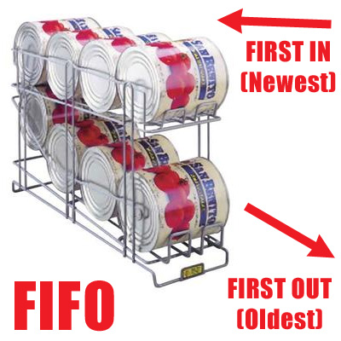
Avoid Food Expiration
When storing food:
- Check the expiration date
  - Many food products are safe to ear beyond the sell-by date printed on the packaging, but manufacturers’ dictate that these foods be removed from retail outlets. The Food Bank is still able to distribute many of those items.
  - Dare to Care works hard to ensure the quality of donated product, but agencies should ALWAYS inspect items as they come to your facility.
  - Please refer to the Food Handlers Guide provide during training for more information on sell-by, use-by and best-by stipulations.
- Store food using the FIFO method
(First in, First out)
It is the responsibility of each agency to supply their site a thermometer. All temperature charts are to be stored for 3 years and the current year. There is a sample temperature chart in the appendix of this handbook.

- Use the food in front firt as it will expire first
Maintain Thermometers & Temperature Charts for Storage:
- Refrigerator
- Freezer
- Dry
Preventing Cross-Contamination of Food: Cross contamination is how bacteria can be spread.
These are specific requirements for the procedures that must be followed for cleaning and sanitizing of food contact surfaces and utensils in the establishment.
Food shall be protected from cross-contamination by:
- Separating raw animal foods (except when being combined as ingredients) during storage, preparation, holding and display from raw RTE foods (such as fruits, vegetables and fish for sushi)
- Separating different types of raw animal foods from each other (such as beef, fish, lamb, pork and poultry) during storage, preparation, holding and display by: using separate equipment for each type, or preparing each type of food at different times or in separate areas
- Proper cleaning and sanitizing of food contact surfaces, equipment and utensils should take place each time there is a change from working with raw foods to working with RTE foods
- Storing food in packages, covered containers or wrappings and cleaning visibly soiled containers before opening
- Separating fruits and vegetables before they are washed from RTE foods
What to do if cross-contamination occurs:
- Do your best to fix the problem
- Set aside the contaminated item so no one can use it
- Ask your supervisor for directions
- Supervisor to call Dare to Care Agency Team
- Discard item ( labeled and dated)
Transporting Food Product:
Specific guidelines for transporting food products from Dare to Care Food Bank warehouse to all associated agencies must be followed to ensure safe handling practices.
- Carriers ( cars, vans, trucks etc) must be clean and free of pests, dirt, debris, liquid spills and odors before food product will be loaded.
- Temperatures of foods must remain in the safety zone at all times.
Refrigerated food < 41°F
Frozen food -10-0°F
Dry – 50 °F to 70 °F

All perishable and prepared food to include meat (fresh and frozen) must be delivered to the agency site and placed into proper storage within 1.5 hours of leaving the Dare to Care Food Bank warehouse.
IMPORTANT REMINDER
This guideline is to protect all parties involved with the transportation of food products to ensure that clients receive optimal quality product. To ensure that food products remain at the appropriate temperature please bring coolers and/or cambros for food storage transportation. Refrain from using garbage bags as this does not keep food at safe temperatures.
**Minimize extra stops on the return to the agency to prevent food spoilage.
Put all perishable (fresh, refrigerated, frozen) products away immediately upon arrival at agency.
CLEANING AND SANITIZING
Cleaning removes food and other dirt from a surface. Although pantries do not cook and serve foods it is important that all areas are clean and free of dirt, insects and rodents.
All areas of distribution from receiving to delivering products must be clean and organized to ensure safe handling of food.
- Daily and periodic cleaning duties should be assigned and inspected by management.
- Cleaning products MUST BE LABELED properly and stored away from ALL FOOD. Always wear protective equipment as needed when using chemicals, for example, gloves.
- Remove all garbage as quickly as possible to eliminate odors and pests.
- Do not clean garbage containers near food storage areas.
- Close all lids on outdoor containers.
- To combat any issues related to rodent and insect infestation, pest prevention measures should be taken regularly. It is the policy of the Food Bank that all partner agencies use a licensed pest control firm to treat and eliminate pest infestation in a timely manner.
Manager/Operator Food Safety Knowledge
The person in charge (PIC) of the establishment must demonstrate to the health department that they are knowledgeable about the prevention of food borne disease and food code requirements.
This knowledge can be demonstrated by:
- Having no critical violations during the current inspection,
- Being a certified Food Protection Manager who has shown proficiency of required information passing a test that is part of an accredited program or local health
- department training or
- Responding correctly to the inspector’s questions and providing satisfactory explanations for each as they relate to the specific food operation.
Note: Per ordinance #11 series 1989 Louisville Metro requires a certified food service manager to be present at all times of operation.
Employees/Volunteers with Illness
Food employees (both permanent and temporary) shall report to the manager or owner information about their health and activities related to diseases that are transmissible through food.
Food employees must disclose to the person in charge (PIC) if they are experiencing:
  - Vomiting, diarrhea, jaundice, sore throat with fever or a lesion containing pus or infected on the hands or wrists (unless protected by an impermeable cover) or exposed portions of the arm.
Food employees shall report if they have been diagnosed by a health practitioner with an illness due to: Norovirus, Hepatitis A, Shigella, Shiga toxin-producing E coli or Salmonella typhi., has been exposed to, or is the suspected source of a confirmed disease outbreak of: Norovirus within the past 48 hours of expo-sure, Shiga Toxin-Producing E coli within the past 3 days, Salmonella within the past 14 days or Hepatitis A within the past 30 days.
The manager or operator shall ensure that a food employee who exhibits or reports a symptom, or who reports a diagnosed illness or a history of exposure to any of the above diseases shall be excluded or restricted from work as specified under 2-201.12.
If an employee or volunteer is sick, it is best if they do not work in the food pantry until they are well so as not to spread disease or infection to clients.

Time as a Public Health Control
Operators that do not serve highly susceptible populations and under certain circumstances with strict controls may elect to use time (rather than temperature alone) as a method to control the growth of pathogenic bacteria in PHF.
Written procedures and strong knowledge of food safety principles are required for this practice. Please refer to 3-501.19 of the 2005 FDA code for more details and contact the health department if you wish to use this type of practice.
Agency Distribution of Specific Food Products
Frozen Products: All meat, poultry and fish must be provided to client in the frozen state. If product is discolored, discard immediately. Pull small quantities of product at a time and replenish as needed.
Fresh Products: All meat, poultry and fish must remain at 41°F and if product is kept in danger zone (41-135°F) for more than 2 hours DISCARD. Pull small quantities of product at a time and re-plenish as needed.
Chilled Perishable: All pre-packaged foods (orange juice) must remain at 41° or less and if product remains in danger zone of 41°-135° for 2 hours DISCARD.
Required Consumer Advisory: Disclosure and Reminder
If an animal food such as beef, eggs, fish, lamb, milk, pork, poultry, or shellfish is served or sold raw, under-cooked, or without otherwise being processed to eliminate pathogens, the permit holder shall inform consumers of the significantly increased risk of consuming such foods by way of a disclosure and reminder, using brochures, deli case or menu advisories, label statements, table tents, placards, or other effective written means.
- Disclosure-identification of the foods that are raw must be depicted on the menu with a symbol (*uncooked or undercooked) and
- Reminder– that written information is available upon request and that consuming raw or undercooked foods may increase risk of food borne illness.

RE-PACKING FOODS
Dare to Care Food Bank requires that all food products received must be distributed in the original container with the approved food label attached.
ONLY EXCEPTIONS INCLUDE:
- Potatoes (can be re-packaged into smaller containers)
- Sweet Potatoes
- Carrots
- Apples
- Squash/Zucchini
- All other produce varieties
Please contact an agency team member if you have any further questions and or concerns.
**FYI…Produce is the only type of food that if re-packaged does not require a label.
FOOD ALLERGY SAFETY GUIDELINES
Remind all clients to read food labels carefully for specific allergens.
Follow cleaning procedures that quickly and safely remove spills while preventing allergen cross contamination.
Inspect area where spillage occurred and remove contaminated product.
Most common allergens:
- Milk, eggs, peanuts, tree nuts ( walnuts, almonds, pecans, hazelnuts, pistachios, cashews, coconuts, pine nuts, macadamia nuts and brazil nuts), fish, shellfish, crab, crawfish, lobster, shrimp, oysters, wheat, soybeans and sesame seeds. Any derivative of these allergens (ex. milk products casein or whey).
High Susceptible Population Regulations
Highly Susceptible Population - persons who are more likely than other people in the general population to experience food borne diseases because they are:
- Immunocompromised, children age 9 and younger, or an older adult
- Obtaining food at a facility that provides services such as custodial care, assisted living such as child or adult day care centers, kidney dialysis centers, hospital, nursing homes or nutritional or socialization services such as a senior center
Prohibited Practices:
- Bare hand contact with ready to eat foods is not allowed
- Time, by itself, is not to be used as a public health control measure, proper temperature must be used
- Any foods served to patients shall not be re-served
Foods not to be served or offered for sale in ready to eat form:
- Eggs & Juices
The new FDA Food Code provides restrictions to children 9 years of age and younger that receive food in a school, day care setting, or similar facility for certain juices. Juice that has a warning label on it, may not be served or offered for sale.
Unpackaged juice that is prepared on site for service or sale in a ready to eat form shall be processed under a HACCP Plan that contains the information as specified in the 2005 FDA Food Code and 21CFR 120.
Pasteurized Eggs or Egg Products shall be substituted for raw eggs in the preparation of:
- Foods such as Caesar salad, Hollandaise or Bearnaise sauce, mayonnaise, meringue, Eggnog, ice cream, and Egg-fortified beverages
- Exception- shelled eggs combined for immediate service may be used if cooked to 145ºF and served immediately as a single meal
- Raw animal foods such as raw fish, raw marinated fish, raw molluscan shell fish, and steak tartare
- Partially cooked foods such as lightly cooked fish, rare meat, soft cooked eggs

ORDERING FAQ
ORDERING & PRIMARIUS
We recommend that agencies designate an online ordering person but have several who are trained in ordering for sustainability purposes.
You may place food orders as much as once a week. We encourage you to at least order monthly.
Depending upon your agency type, you will have access to certain resources of DTCFB through online ordering, including:
- Salvage (damaged goods donated by retailers)
- Food Bank (items donated to and purchased by DTCFB)
- Bread/ Produce/ Surplus Items (items without shared maintenance)
- Emergency Food (Distribution Centers only)
- USDA/ TEFAP (for those who qualify)
- Hunger-Free Kentuckiana Co-op (partner members have the opportunity to apply for participation in the co-op program to purchase food for any of their programs)
NAVIGATING PRIMARIUS
In order to receive products from Dare to Care, partner agencies must place orders through the online ordering portal, Primarius. Inventory changes frequently, so we recommend that partner agencies check the website early and often.
If you have trouble opening Primarius, please be sure your web browser meets the following specifications:
Supported Browsers:
Site Requirements:

ACCESSING PRIMARIUS
The online ordering system, Primarius, can be found by visiting http://daretocare.org/other_agencies/login.
Bookmarking this web address into your web browser’s “favorites” will allow for quick and easy access in the future.

LOGING INTO THE PARTNER AGENCY HOMEPAGE & PRIMARIUS
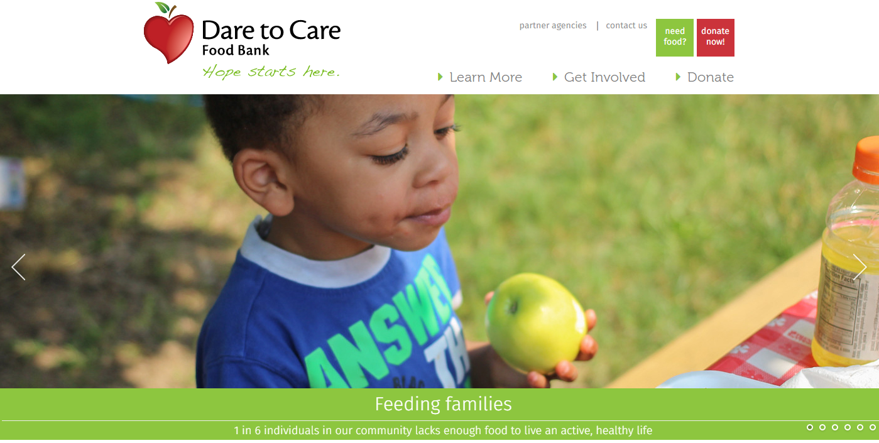
To place an order, you will first need to login to the Partner Agency Portal page of the website. To access this page, you will go to daretocare.org and select “partner agencies” in the top right hand corner as shown below.

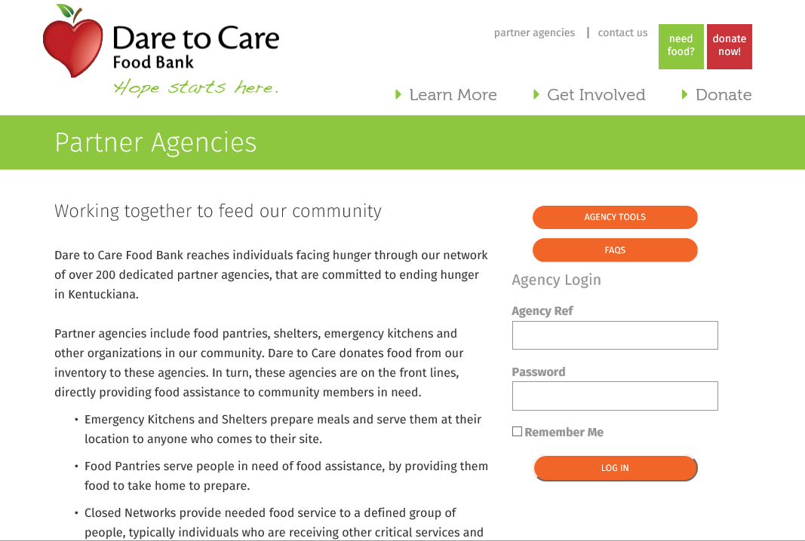
Once you click on “partner agencies”, you will be directed to the page show below. Here you will see information about Dare to Care’s different partnership classifications, as well the Agency Login portal on the right-hand side of the page. To login to the partner page and proceed to place an order, you will need your agency reference number and password as seen below.

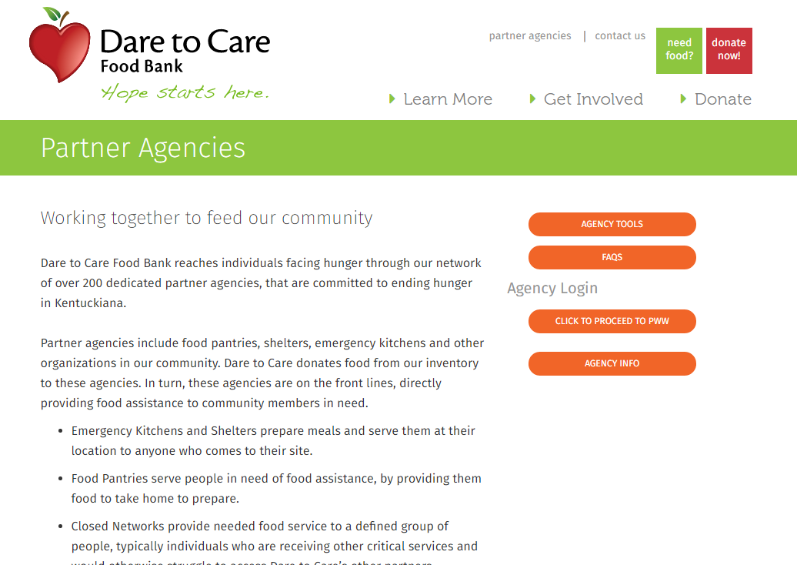
Once you enter your agency reference number and password and select “Log In”, it will take you to the Partner Agency Home Page as seen below. Here you have a few options to select from to access information and resources available to your agency.

Under Agency Tools (the first orange button on the right), you will find a variety of documents that will help you operate your pantry, soup kitchen or closed network site. Here you will find the manual that walks you through how to place an order, food safety training tools, and a variety of documents that may be helpful to your agency. 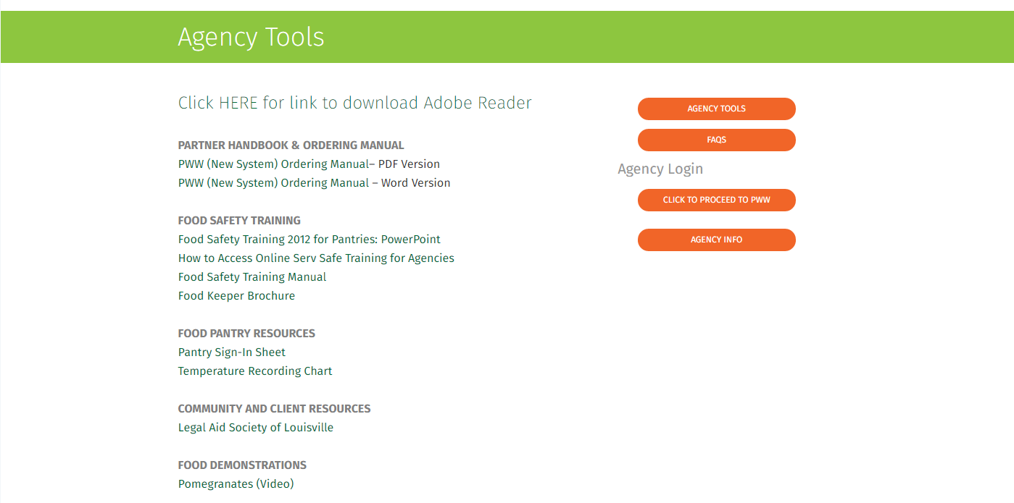
Under Agency Partnership FAQs you will find a series of Questions and Answers that pertain to Dare to Care’s partner search and onboarding process. This is a helpful section for any organization interested in partnership with Dare to Care.
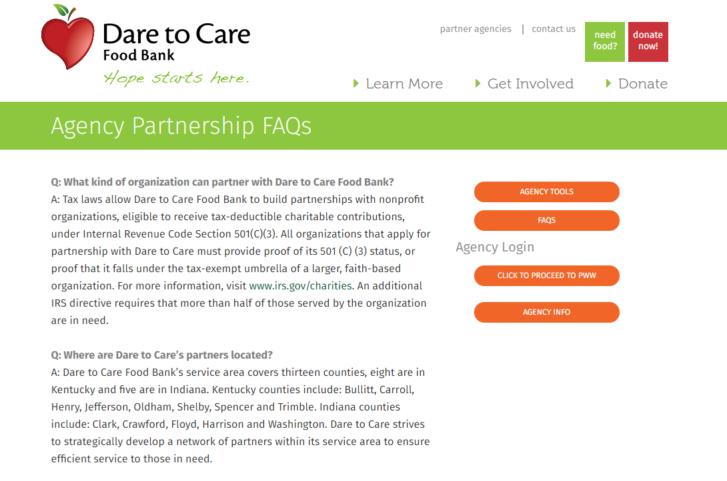

AGENCY INFO is the most important tab out of all of these. Here you will find notes and important information from the Partner Development team. Please be sure to take a moment to go to this section and read this information before proceeding to place an order.
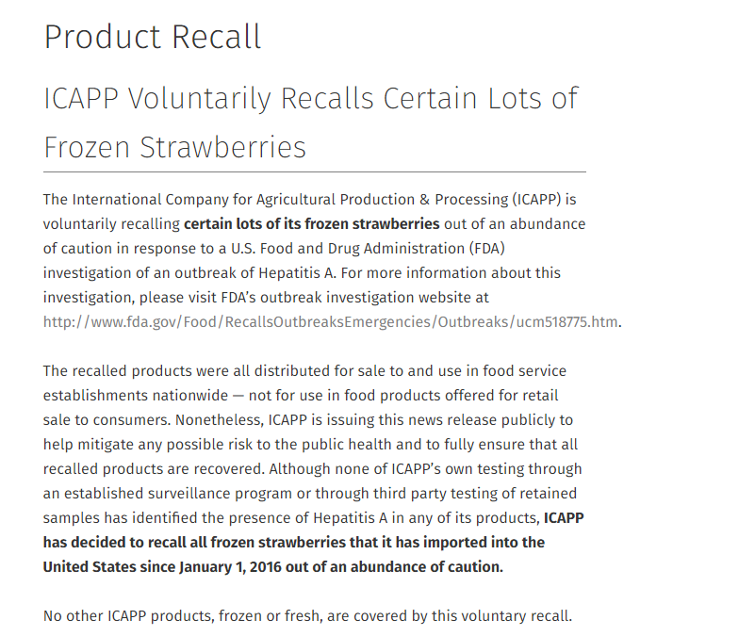
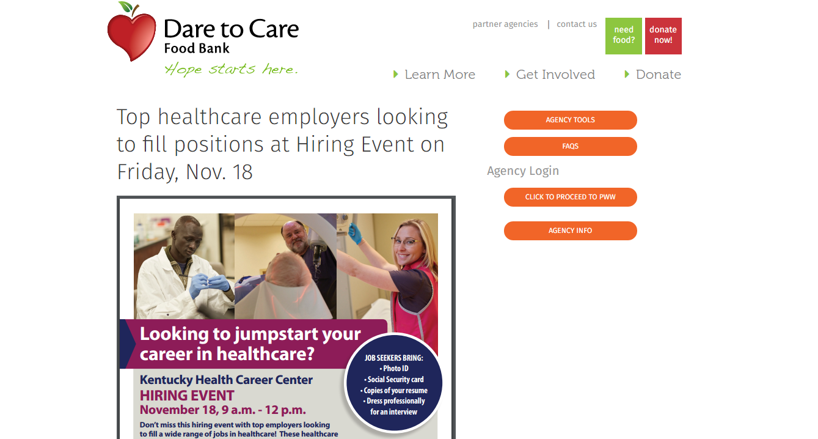

Finally, to login to Primarius to place orders, submit statistics and enter inventory (if your organization distributes USDA commodities in Kentucky), you will click the button that says, “Click to Proceed to PWW”.

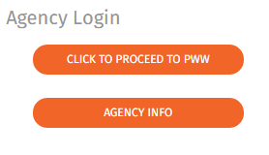

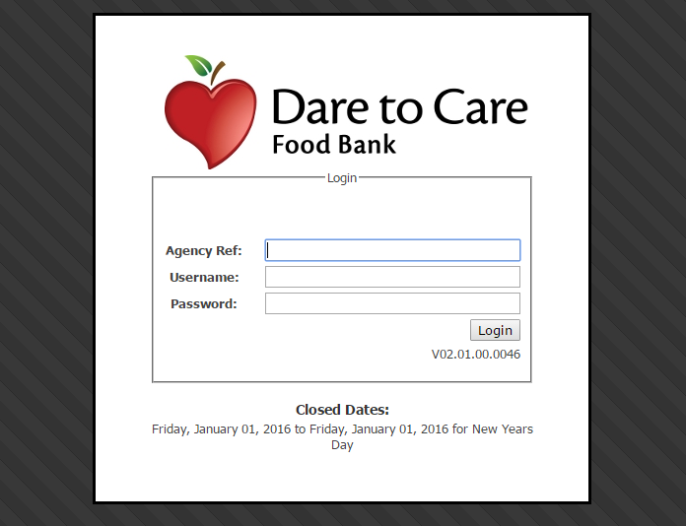
Once you click that button you will be redirected to the Primarius Web Window (PWW) and will need your agency number, username, and password to login.
Please note that your agency number, username, and password are all given to the main contact when attending partner training. This information should never be given to unauthorized personnel. Please notify Dare to Care immediately in the event of staff changes.

BEGINNING AN ORDER IN PRIMARIUS
Once you have entered your credentials to enter PWW, you will be taken to the main Primarius Web Window page shown below. Here you can place orders, enter statistics and see the status of current and past orders.
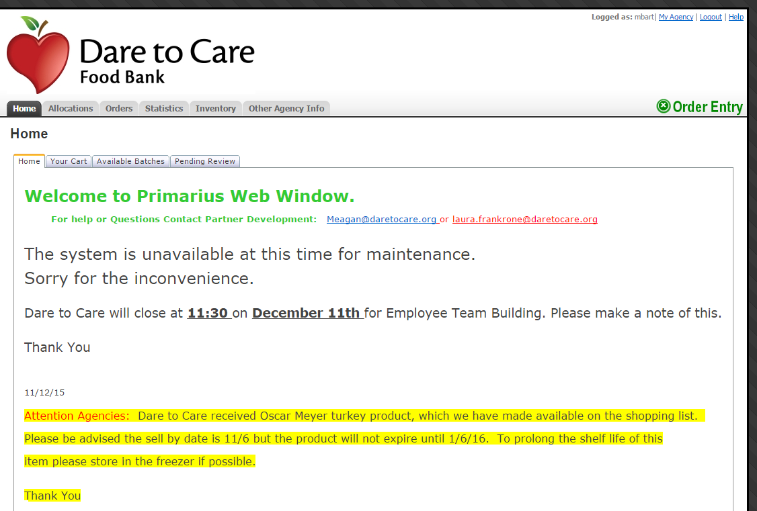
To place a Food Bank order, click “Order Entry” located on the top right corner of your PWW home page.

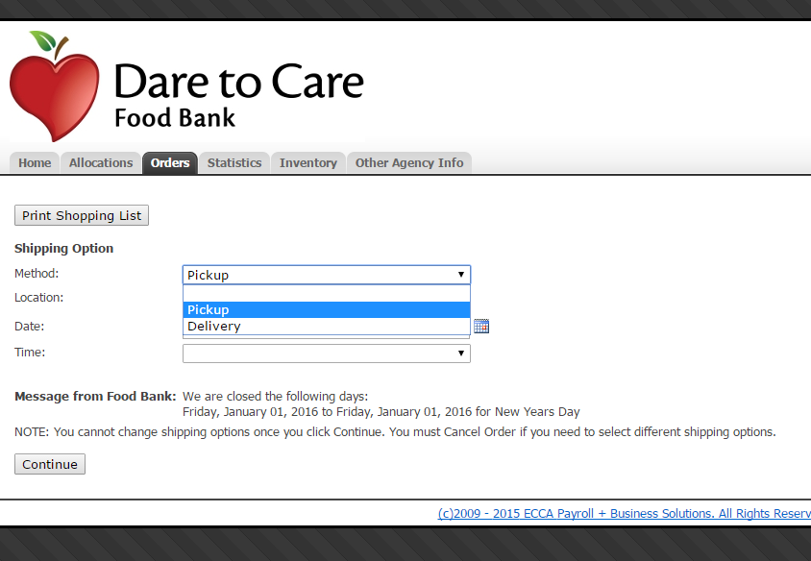
You will then be directed to the page below which will ask you to select a day, time and dock for when you’d like to pick up your order.
Step 1
Steps to begin order:
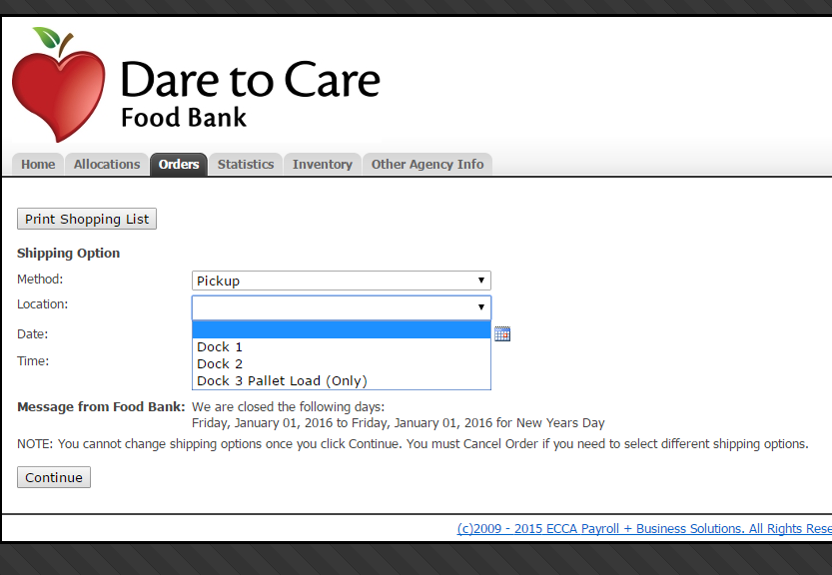
- Select “Pick Up” as your shipping method from the first drop down option, as your agency will be picking up this order from the food bank.
Step 2
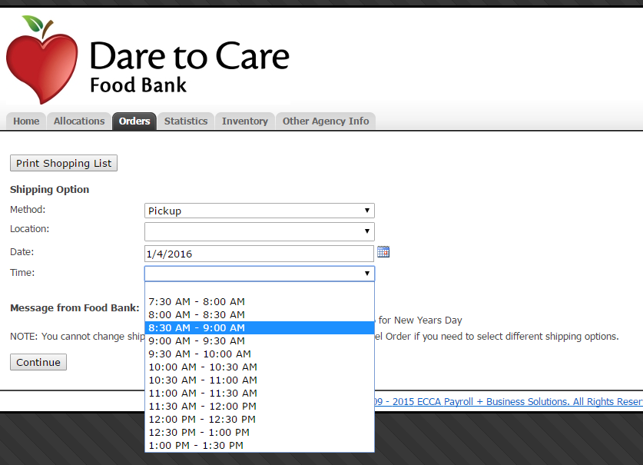
- You’ll then select a dock location for where you will pick up your order. You’ll choose either Dock 1 or Dock 2 when picking up in a car, van, pick-up truck, etc.
Step 3
- Then you will select the date you’d like to come pick up your order using the calendar icon to the right. All orders are on a 48 hour pick up schedule. Ordering after noon on a Monday, for example, is the same thing as ordering before noon on Tuesday. The system will automatically give you the next available pick up date.
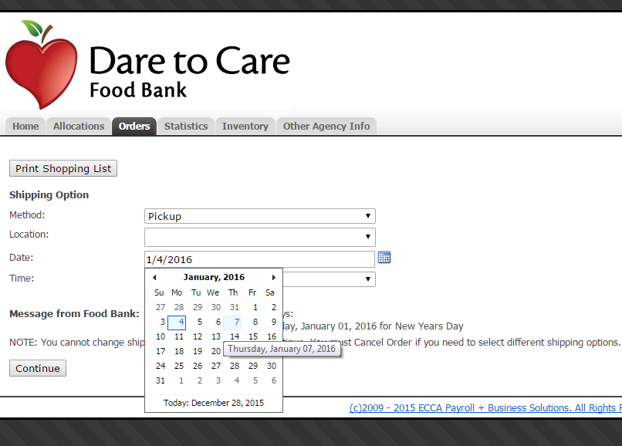
- You’ll then be able to select a time to pick up your order on the selected day. Our dock opens at 7:30 AM and closes at 1:00 PM. Dock pick up times are scheduled in 20 minute increments to allow enough time for your agency to load the products into your vehicle. The system will tell you the times available based on the dock and day you have selected. If the dock time you were hoping for is not listed, that means that time has been taken. You may select another dock to few additional available times.
Step 4

Once you have your dock, date and time selected, click CONTINUE on the bottom left of the page to view your shopping cart.
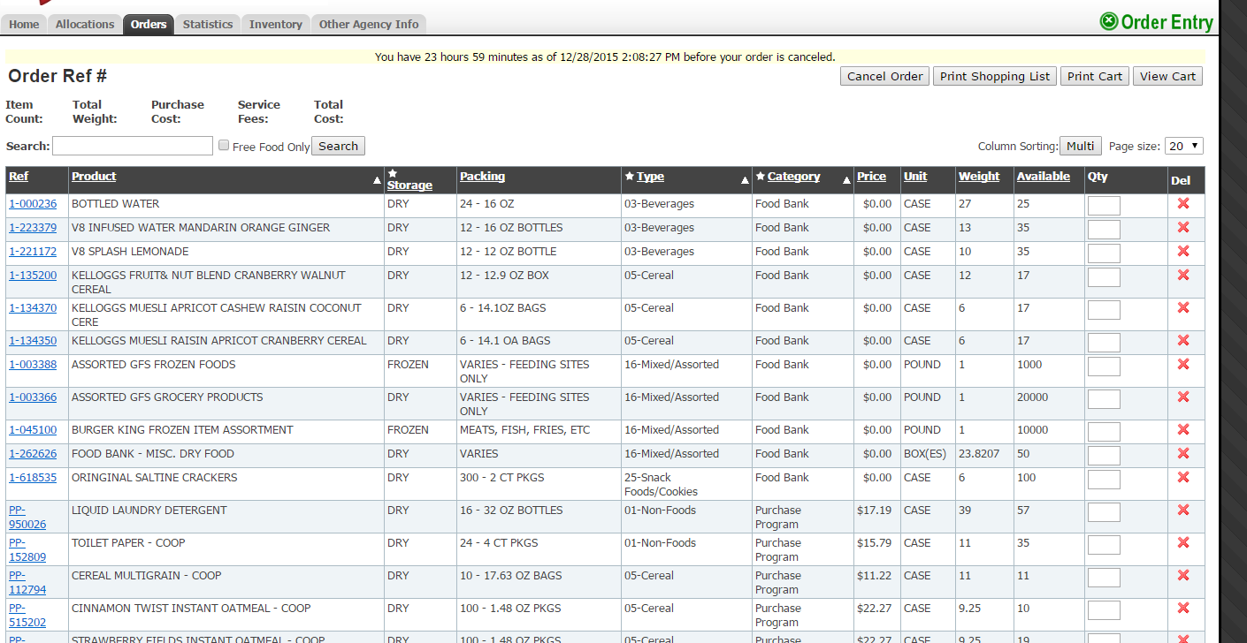

When you get to your shopping list, you will see a number of fields that explains each product.
What those fields mean:
Ref: The number given to the product by the Food Bank.
Product: The manufacturer description or name of the product given by the Food Bank. Sometimes this can have “miscellaneous” in the description. This means that the product has been donated to us and it is various frozen or dry product.
Storage: This is how the food is stored – dry, frozen or refrigerated grocery product.
Packing: This tells you what the products
Type: This specifies the general category the product may be found, such as Beverages, Cereal, Snack Food, etc. Again, this field can read “miscellaneous/assorted” if a product does not fall under one of Dare to Care’s defined categories.
Category: There are three category types – Food Bank Food, Salvage and Purchase Program.
Food Bank food is product donated to Dare to Care by retails, manufacturers, individuals, etc. Salvage is product retailers are unable to sell. These items might be slightly damaged, but are still safe to distribute. Purchase Program products are items that we have purchased. You will not see these items on your shopping list unless you are logged into your Co-op account.
Price: This will always read $0.00, unless you are placing an order through the co-op program.
Unit: We have two main units – Cases and Pounds/Varies. Products ordered in pounds should be ordered in increments of 5 pounds or more.
Weight: This is the weight of the product per unit in pounds.
Available: The amount of product your pantry/feeding site may order.
Quantity: You may specify the amount you’d like to order up to the available amount listed in the column before.
The shopping list can be filtered by each header. Once it is set up, the system will keep it that way until it is changed. You may also search for products using key words in the search box about the start of the list.
Please be aware that based on the ebb and flow of the Food Bank and because we work off donations, sometimes this list will have 20+ items and others it will have 5.

SUBMITTING YOUR ORDER IN PRIMARIUS
Once you have picked all the items you’d like to order, click VIEW CART. 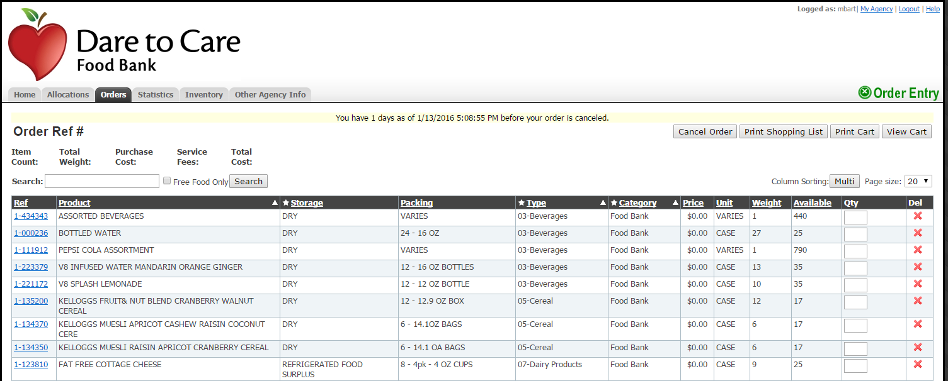
A list of all the items you selected will appear in your cart. From here you can delete items or go back to the shopping list if you think there is something you forgot. If everything is correct, click CHECKOUT.
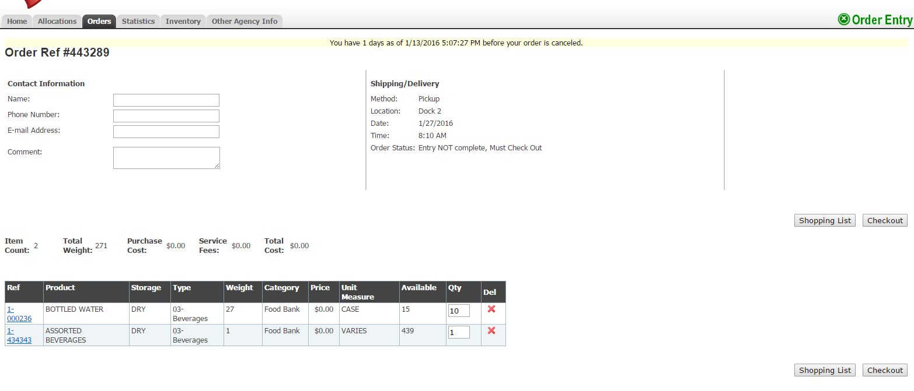
Once your order is submitted a thank you message will appear on the screen with your order reference number. The system will send you an email once the order has been reviewed by a member of the PD team.
Please note: While we don’t like when it happens, it may sometimes occur that not all of the product you initially ordered . This doesn’t happen all the time, but unfortunately items can be left off for a couple of reasons:
- Human Error: Sometimes our inventory can be off because of human error when entering quantities into the system.
- Unauthorized to Operate a Forklift: Some of our Warehouse staff come from a contracting organization and are unauthorized to use a forklift. So, an item may be on the shopping list, but when the order is picked, the picker will skip over this item because they couldn’t retrieve it.

SUBMITTING STATISTICS IN PRIMARIUS
From the main Primarius page, you can access different agency information and resources, one of which is statistics. Statistics are very important to Dare to Care because this is how we report the organization’s activity. We use this information to apply for grants, inform and engage donors, as well as measure the impact we are making on the community overall. Therefore, it is important that this information is as accurate as possible and we need your help to do so!
Click the STATISTICS tab to view your statistics.
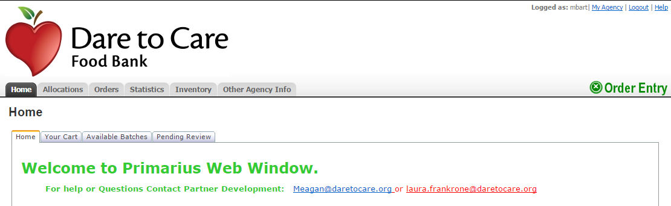
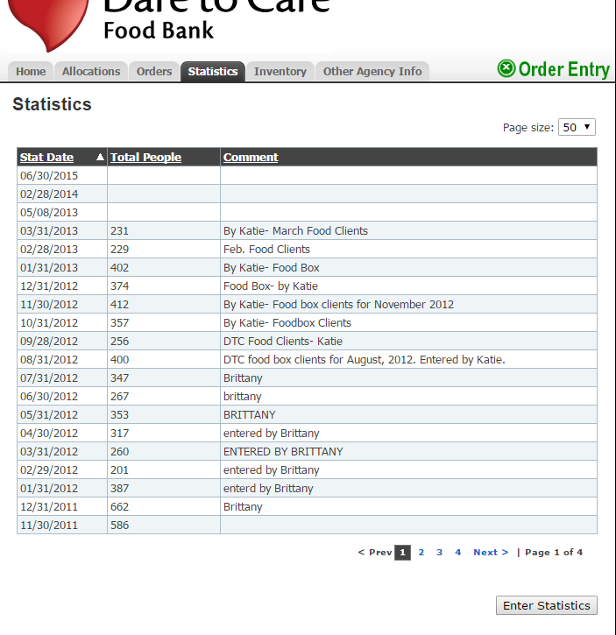
A list of past statistical information will be located under this tab. Please review this information to ensure your monthly statistics are present. If there are any months not present (6 months to present) please take the time to input these numbers. If over 6 months old, please contact the PD team with that information.
Click ENTER STATISTICS at the bottom right-hand corner to enter your monthly numbers.

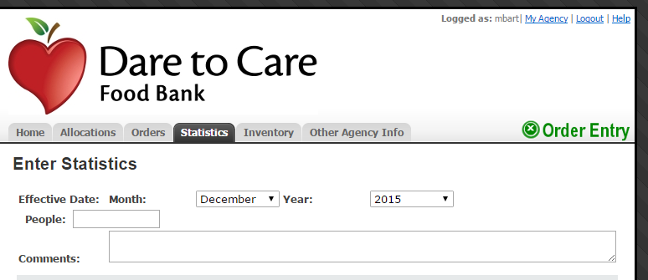
Select the month and year for which you’d like to report your statistics.
There is also a comments section where you can explain any changes in statistics beyond your normal ranges.
You are only required to fill out the information pertaining to your program. These will be assigned to you within your statistics tab. (You will likely never see as many fields available as shown to the right.) If you are unsure of what you should be reporting, please contact the Partner Development team.
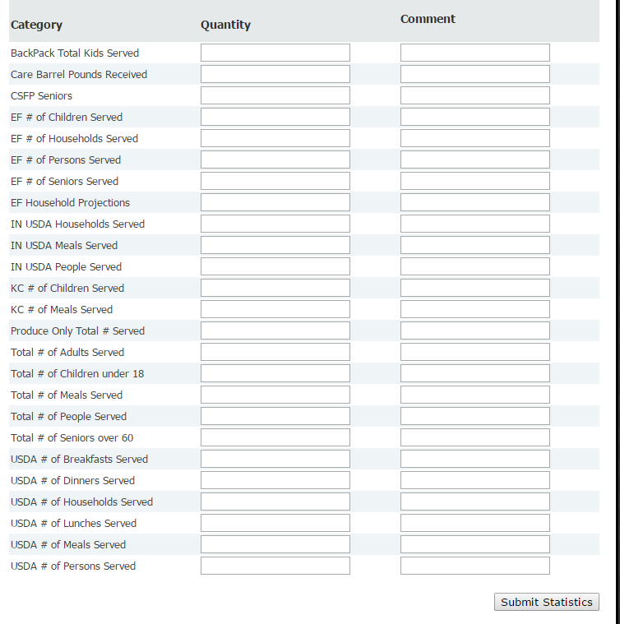
Once you have entered your statistical information, click SUBMIT STATISTICS.
Once you submit, you will receive an automated message thanking you for the information and can click back on the Statistics Tab to view your submission.
REMINDER: All statistics should be reported by the 3rd of each month for the previous month’s distribution. For example, all statistics for the month of January should be reported by the 3rd of February. If statistics have not been entered in a timely manner, the system will not let you place an order.
WHAT STATISTICS DO I REPORT?
I am a Food Pantry…  - Total # of People Served  - Total # of Seniors over 60  - Total # of Children under 18  - Total # of Adults | I am a Food Pantry or Distribution Center that sometimes gives “produce only”…  - Produce Only Total # Served (Total # of people in each household who ONLY received produce)
I am a Community Kitchen…  - Total # of Meals Served (this is a plate count, i.e. second helpings)  - Total # of People Served (this is a head count) | I am a Kitchen that receives USDA from Dare to Care…  - USDA # of Breakfasts Served  - USDA # of Lunches Served  - USDA # of Dinners Served  - USDA # of Meals Served
I am an Indiana site that only distributes USDA products…  - See Monthly Outlet Report provided at training | I am a Pantry or Distribution Center that receives USDA from Dare to Care…  - USDA # of Households Served  - USDA # of People Served

SUBMITTING INVENTORY IN PRIMARIUS
THIS IS ONLY FOR AGENCIES PARTICIPATING IN THE KENTUCKY USDA, TEFAP PROGRAM. If your agency receives and distributes USDA commodities in KENTUCKY through your partnership with Dare to Care, you will also need to report monthly inventory through Primarius.
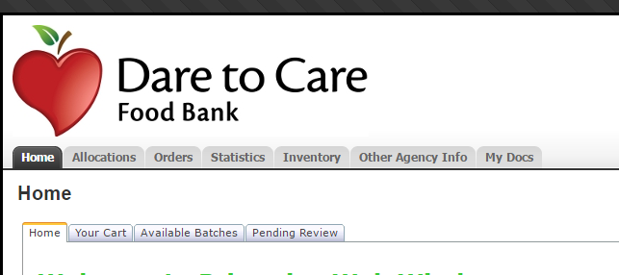
Select the inventory tab

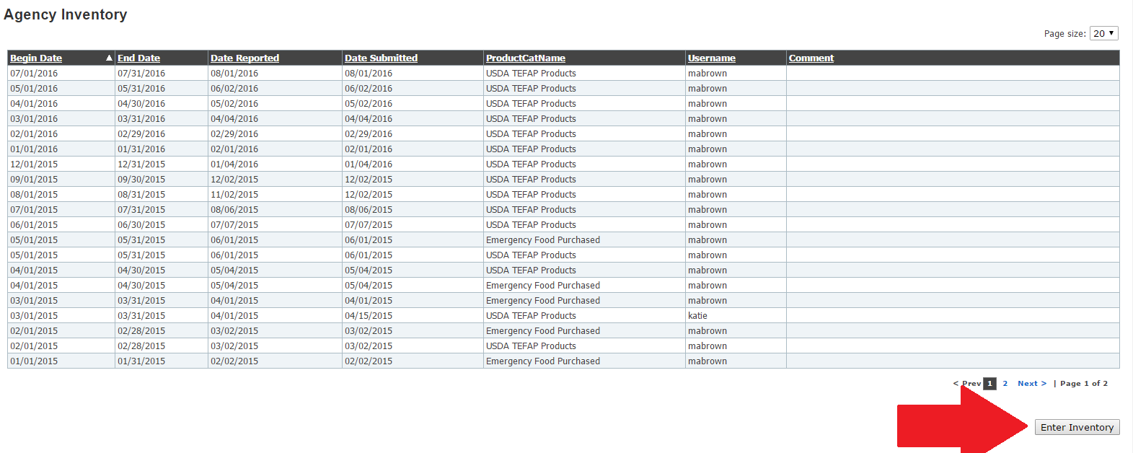

Select “enter inventory” to enter remaining inventory from the previous month

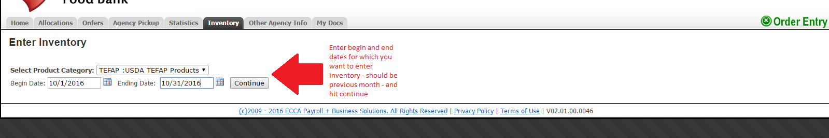
Enter beginning and ending dates for which you want to enter inventory – should be for the previous month – and hit “continue”

Once you enter the dates for which you are entering inventory, you will be directed to a page that looks like the below. This will list the USDA products from the previous month.
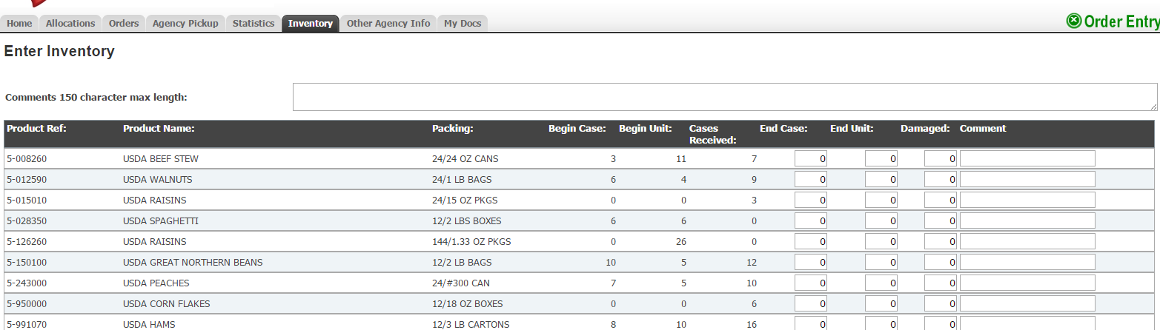

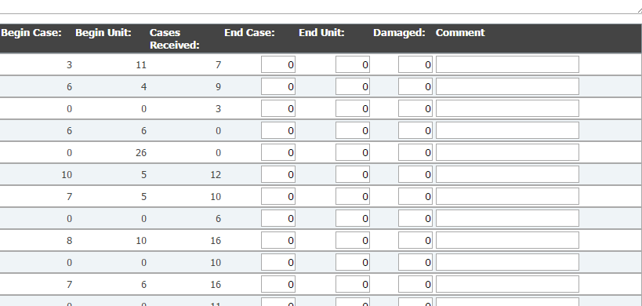
You will be able to enter the amount of cases and/or units you have left for each product received from the previous month as shown below. If any products were damaged you will indicate that here and leave a comment to explain the situation. Also know there is a formal process for reporting damaged USDA products.

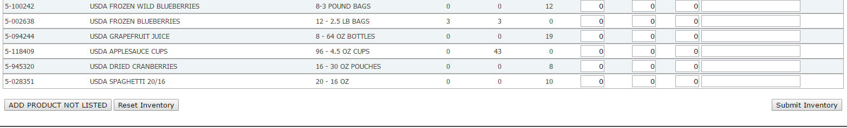
Once you have entered all remaining USDA inventory, you will select “submit inventory” in the bottom right section of the page.

PICK-UP & DELIVERIES
You can pick up your food bank orders at Dare to Care Food Bank, 5803 Fern Valley Road, Louisville, KY 40228. You may pick up your items at Dock 1 or 2 on the right side of the building. Please provide adequate transportation and personnel to pick up food from the Food Bank.
Dare to Care will make every effort to have your order ready at the dock for pick up and deliver orders in a timely fashion. If you have questions regarding your delivery or pick up, please contact the Partner Development team.
ORDER PICKUP POLICIES & PROCEDURES
Once an order is placed in Primarius, all partner agencies are expected to retrieve those items on the scheduled date and time that you have selected. Agency representatives should arrive on time, or a few minutes early for their scheduled pickup time. Please understand that tardiness causes delays and disruption to the schedule. Representatives may have to wait until all other agency representatives have loaded product into their vehicles.
**It is the policy of the Food Bank that agencies must bring a freezer blanket if transporting refrigerated or frozen product from the food bank. This ensures that proper temperatures are maintained during transportation as stated in the Partnership Agreement and Food Safety Handbook.
Agency Responsibilities:
- Arrive on time for your scheduled appointment
- Bring adequate vehicle to transport your items
- Load all items within the allotted timeframe
- Ensure you have enough volunteers to load your vehicle
- Notify the PD team if you encounter any delays in retrieving your order

CHECK-IN
All agency orders are available at two agency dock doors on the right side of the building. Please check in with Ehab, Dare to Care’s dock manager upon arriving at the food bank. There is a separate entrance for agency representatives. Representatives will be asked for their organization name, agency number and photo ID upon arrival. Once you have checked in, you will be able to retrieve your order and have a 20 minute window to load your items.
CHECK-OUT
The Food Bank is not responsible for loading vehicles. If you have a large order, please bring someone to help you load your order. Warehouse staff will gladly assist with forklifts and pallet jacks if necessary.
MISSED OR CANCELLED APPOINTMENTS
If you miss your scheduled pick-up time, contact the Partner Development team immediately. Agencies are expected to make alternate arrangements with the PD team in order to retrieve items within 48 hours. If you do not discuss alternate plans with the PD team within that timeframe, your order is subject to be distributed to other agencies so we can move that product.
**As stated in the Food Safety section of this Handbook, it is the responsibility of the partner agency to transport all items in a safe and secure manner. Please make sure your vehicle has the capacity to adequately and safely carry all your ordered items.
PRODUCT RECALL PROCESS

When a recall has been issued on any product, the Foodbank receives a notification. Dare to Care will inspect our inventory list to determine if the product was donated or purchased by the food bank.
Partners will be notified immediately when a recall is issued. Partners will receive an email notification from a member of the Partner Development team and it will also be posted to the website.
When a recall is issued, Dare to Care will provide you with the necessary product information to inspect your inventory. Please check for the following:
- Name of manufacturer or brand
- Packaging Size
- Serial/Lot Numbers
- Location/are of applicable recall
- Any special instructions for the disposal or return of recalled items
If your agency has received any recall items, please take the follow action:
- Check your DTC products and any other donated products for the appropriate product.
- Dispose of any remaining product by putting it in a dumpster and pouring bleach overtop.
- Promptly provide recall information to clients who may have received the affected product.
- Notify Dare to Care of the products you received, about how much had been distributed and how you disposed of the remaining product.

TIPS & TRICKS
Start small. It’s okay to have a few practice runs before you place a large order. If you have more than one person on your staff, as a team, order together and see the order come to life by coming as a group for pick up. Then, you may get a feel for what 10 lbs. of crackers or toothpaste looks like in person.
It never hurts to ask. If you would like to know more about an item before ordering, or are confused about packaging or pick-up times, contact the Partner Development Team. They are poised to assist you!
Consider your need. Before ordering, ask yourself, “Do I have enough storage for this item?” Consider your turnover, the older items you already have on stock and the needs of your community. You can keep track of the total weight of your order as you order.
Get familiar with weight. A weight conversion chart is a handy tool for visualizing certain products expressed in lbs./varies/#s. It’s helpful to envision yourself grocery shopping and use what is already familiar to you, i.e. retail meat usually comes in 1 lb., it would take a lot of toothbrushes to equal 1 lb., etc.
Use the Food Bank lingo. We know we use a lot of inside words that can be somewhat confusing. See the glossary for some you may see.

FAQS
I forgot my agency reference number/ username/ password. Contact the Partner Development Team at (502) 962-6674 and we will be happy to help you.
When is the best time to order? Oftentimes, the products we receive are just as much as a surprise to you as they are to us. There is no “good” time to order as product is constantly moving in and out of the warehouse.
Why can’t I log in? The ordering site will lock you out automatically if you are unable to enter your statistics. To regain access, enter in the prior month’s numbers or you may call the Partner Development Team for assistance.
After logging in, I receive a message saying my agency cannot place an order. How to proceed? Your agency has been suspended temporarily. This may happen for several reasons but most often when an agency fails to report monthly statistics in a timely fashion. If you discover your agency has been suspended, contact the Partner Development Team at (502) 962-6674; we will help you understand and resolve any issues.
Can I log in, work on my order and come back to it later? Yes, you can log out and the system will save the selections you have made for 24 hours only. However, we highly recommend that you order and check out immediately. The longer you let an order sit, the more vulnerable it is to other agencies who may desire the same items.
Is it possible to view the shopping list to check product availability without placing an order? Yes, however you have to select a date and time for a pick-up before the system will allow you to proceed to the shopping list. Note: It is recommended that you select a pick-up date and time that will most likely work for you should you decide to place the order after all. Once you get to the shopping list, you may do one of three things:
- If the product/s you seek are not available at this time, you can log back in within 24 hours and check again; the system will “remember” your order and bypass the scheduler.
- If you do not log back into the system within 24 hours, the system will automatically void the order; you will have to begin a new order the next time you log in.
- If you determine the shopping list includes all that you hoped to order, make your selections and submit the order.

Why can’t I make changes to my order? DTCFB is fortunate to have more than 300 community partners. Unfortunately, this also makes it difficult to attend to changes to each order an agency submits.
May I change the date or time I have scheduled for order pick-up? Yes! If you have not moved beyond the screen page where you selected the date/time for pick-up, you may change it yourself. If you have moved beyond the scheduling screen page, you must contact a member of the Partner Development Team at (502)962-6674 and we will make the changes for you.
If my order is ready, why is the warehouse still pulling items when I arrive? We await your arrival to pull your frozen items, to ensure the best quality of product.
May I add more volunteers for pick-up? Of course! Simply send a notice on letterhead or email which requests that DTCFB add a certain individual as an authorized pick-up volunteer.
My agency is approved to order USDA products. Sometimes when I log into the DTC website, I cannot see a USDA shopping list. Why? DTC closes the USDA food shopping list during the last week of each month. This gives our staff an opportunity to take inventory and re-stock. The USDA shopping list is usually refreshed and back on-line during the afternoon of the last Wednesday of each month. Also, USDA is not ordered like other food items. To select USDA products, be sure to click the “Allocations” tab on the left side of your log-in page.
I can’t remember how to report my agency’s statistics. What to do? Log into your agency’s PWW homepage → click on the “Statistics” tab → scroll to the bottom of the page and click “Enter New Statistics” → select the last day of the month for which you are reporting → enter your statistics.
I don’t see any fresh produce or bread on the shopping list- does this mean it is not available to my agency? Bread and produce is selected by your volunteers at the warehouse and weighed by the staff. There is no limit on the amount of produce you can take, except for fresh potatoes. Each agency is allowed 24 loaves of sliced bread, and may take unlimited bagels, muffins, etc. Please be sure to only take the amount of food you can haul and distribute.

TEMPERATURE RECORDING CHART

- Name of Agency: ________________________

- Type Storage ____________________________

Month | Day | Temperature | Checked By | Month | Day | Temperature | Checked By

APPENDIX
RECOMMENDED TEMPERATURES:
Freezers: -10°F to 0°F
Coolers: < 41°F
Dry Storage: 50 °F to 70 °F

Agency Monitoring Visit Checklist
Bi-annual Monitoring visits are a requirement for partnership with the Dare to Care Food Bank due to regulations set by the government and Feeding America. The checklist below provides a resource for you when preparing for your bi-annual visit.
- Client in-take sheets
These must be kept on file at your food pantry from 3 years, plus the current year.
- Temperature Logs
These must be posted on each refrigerator, freezer, and dry storage area. They must be checked on a weekly basis and kept on file at your pantry for 3 years.
- Thermometers
There must be a working thermometer in each refrigerator, freezer, and dry storage area. The temperatures of each must be checked on a weekly basis if not more frequently.
- Food is stored six inches from the floors & walls
- Site is free from infestation
There should be a contract or a relationship with a licensed pest control firm.
- Appearance and upkeep of storage area
- Posted hours of distribution
- Statistics
Numbers of clients served should be reported monthly and kept on file for 3 years plus the current year.
Additional Guidelines for Agencies participating in the USDA program:
- Specified TEFAP client in-take forms
These must be on file for 3 years, plus the current year
- And Justice For All Poster Displayed (and Written Notice of Beneficiary Rights if a faith-based organization.)
- Civil Rights Training Form?

Food Expiration Date & Shelf-Life Guidelines
The information contained in the charts concerning food safety dates and date codes is based on USDA guidelines, consumer education and information reports.
Date Examples | Examples | May be found on | What it Means | When to Dispose
Expiration Date | "expires 12/15/2013"  "do not use after 12/15/2013" | baby food  baby formula nutritional supp. medicine vitamins | The manufacturer cannot guarantee the nutritional value of the product after this date | Dispose of this product on this date
Pack Date | Open:  "packed on 12/15/2013"  Closed: "22:5214125" | canned foods crackers  cookies  spices | This is the date the food was packaged  Purpose is to assist retailer with First in First Out | Has a very long shelf life. Refer to individual product chart
Use by Date  (also called a Quality Date) | "best if used by 12/15/2013"  "use before 12/15/2013"  **do not confuse with soda "expiration" dates that state "do not use after" | crackers  cookies  cereal  salad mixes beverages | This is the manufacturer's recommendation for when the food will be at peak quality | Let your senses of sight, taste and smell guide you
Sell by Date  (also called a Pull by Date) | "sell by 12/15/2013"  "pull by 12/15/2013 | dairy | CT Law determines dating for dairy products. Stores cannot sell this product after the date. | If the food has been properly handled it is safe to eat for days/weeks beyond date, refer to product chart.
Source: FoodShare.org, http://site.foodshare.org/site/DocServer/Food_Storage_and_Shelf_Life_Guidelines.pdf?docID=5822

Product | Estimated Shelf Life of Unopened Product | When to Discard
Baby Food | Use by/expiration date | Broken seal, expired
Bread/Bakery Items | 3-10 days | Visible mold, package defect
Boxed Dinners | 2-5 years
Cans/Bottles | 1-5 years | Bulging, severe dents
Cereal, Chips, Crackers | 6 months – 2 years | Stale, infestation
Cheese | Soft 7 days, hard 6 months | Visible mold
Condiments | 1 year
Eggs | 3-5 weeks after purchase | Broken, infested, malodourous
Dry Beans | 1-2 years | Infestation, mold, open
Frozen Items | 6 months – 1 year | Freezer burn, malodourous, previously thawed
Items in Jars | 2-5 years | Cloudy liquid, beyond date
Juice (Refrigerator) | 3 weeks | Bulging, leaks in packaging, discoloration
Mayonnaise | 2-3 months | Discoloration, separation, bulging, beyond date
Meat (Refrigerator)  Poultry  Beef, pork, lamb  Ground meat  Cured meat | 1-2 days  3-5 days  1-2 days  5-7 days | Malodourous, discoloration, previously thawed, infestation, open
Milk (Refrigerated)  Milk (Shelf Stable)  Milk (Frozen) | 1 week  1 year  3 months | Bulging, beyond date, discoloration, malodourous, leak in packaging
Mixes (cake, muffin, etc.) | 12-18 months | Infestation, open
Prepared Salad/Dips | Use by date | Past date
Rice & Pasta | 1-3 years | Infestation, mold, open
Yogurt & Sour Cream | 1-3 weeks | Mold, open, malodourous

Sealed, Refrigerated,  Processed Product | Discard when Unopened | Discard when Opened
Cooked Meat | 3 to 4 days | 3 to 4 days
Shelf-stable Sausage | 6 weeks | 3 weeks
Corned Beef, uncooked, and in pickling juices | 5 to 7 days | 3 to 4 days
Vacuum-packed Dinners | 2 weeks | 3 to 4 days
Bacon, Hot dogs | 2 weeks | 7 days (1 week)
Lunch meat | 2 weeks | 3 to 5 days
Ham, fully cooked | 7 days | Sliced, 3 days  Whole, 7 days
Meat, canned & shelf stable | 2 to 5 years/pantry | 3 to 4 days

GLOSSARY
Agency/ Partner Agency: An approved feeding program that distributes food to the needy, ill, or infants in our 13 county service area. These may include pantries, super pantries, soup kitchens, closed networks and any other approved organization.
Assorted/ Miscellaneous Product: A mixture of items (i.e. Pizza Hut Assorted may be cheeses, sauces, condiments, etc. or Pork Assorted may be any kind of cut)
Bulk Product: This item comes in a large size and is best used by community kitchens.
Capacity: Refers to the range of capabilities and resources an organization needs to be effective. Circumventing
Choice Model: A model that a feeding program adopts in which clients are able to choose which items they’d like.
Client: Any person who self-declares they are in need of food assistance and receives food through the Dare to Care network.
Commodities: Food donated through USDA that is administered through CSFP and TEFAP programs.
CSFP: A federal (USDA) nutritional assistance program intended to serve income-eligible seniors.
DTC: DTC is an acronym for the Dare to Care Food Bank.
Discrimination: The unjust or prejudicial treatment of different categories of people on the grounds of race, color, national origin, age, sex, religion, political affiliation or disability.
Foundational Food: A food stream consisting of nutritious, basic foods that serve as a strong “foundation” for serving clients. Foundational Food is made available to Dare to Care partners bearing “Distribution Center” (DC) status; these are the Dare to Care partners with the strongest capacity strength and those willing to serve as the leading hunger-relief agency for a large service area or county.
Food Insecure/Insecurity: When an individual or household may not know where they will obtain their next meal. The USDA describes food insecure households as not having reliable access to healthy food resources to lead active and healthy lives.
Food Bank: A nonprofit, charitable organization qualified under Section 501©3 of the IRS Code of 1986 to receive donated products and distribute food to food pantries, soup kitchens, and other authorized organizations that provide food or meals to persons in need on a regular basis.
Food Pantry: A qualified, nonprofit, 501©3 organization that is part of the Food Bank’s network that distributes food to low-income families to relieve food insecurity and distress.
Grievance: A formal process of identifying and resolving a complaint or unjust act.
Household: A group of related or non-related individuals residing in the same residence who buy and cook food together. It can also mean a single person living alone.
Hunger: A feeling of discomfort caused by a lack of food.
Infant: A minor child as defined by the law of the jurisdiction in which the child resides.
Ill: A person suffering from physical or mental injury, malnutrition, disease or infection which significantly impairs physical health, a person partially or totally incapable of self-care; including incapacity due to old age.
Needy: A person who lacks the necessary means to survival, including physical, mental, or emotional well-being as a result of poverty or temporary distress.
Nonprofit: An IRS recognized 501©3 organization that works to benefit the general public and does not profit from its operations.
Poverty: A low income level established by the United States department of health and human services.
Primarius: Dare to Care’s ordering system in which each partner will receive a login and can order food weekly via the internet.
Proxy: Any person with signed consent who is eligible to pick up food for a client that is unable to do so themselves.
Recall: A process in which a product has been deemed unfit for consumption due to contamination which involves health and safety hazards, requiring such products to be disposed of or returned to the original product vendor.
Retail Product: The item will come in retail packaging, much like you would find at Kroger or Wal-Mart, and is good for individual distribution.
Salvage: Various donated products to Dare to Care from local grocery stores. This could range from canned goods to personal care items and will appear as “mixed” product on the shopping list.
TEFAP (The Emergency Food Assistance Program): A Program administered by the USDA to provide food to those in need at a certain level of income.
USDA: The United States Department of Agriculture responsible for federal programs related to agriculture.
Varies: Another word for lbs., also represented by the # symbol.

