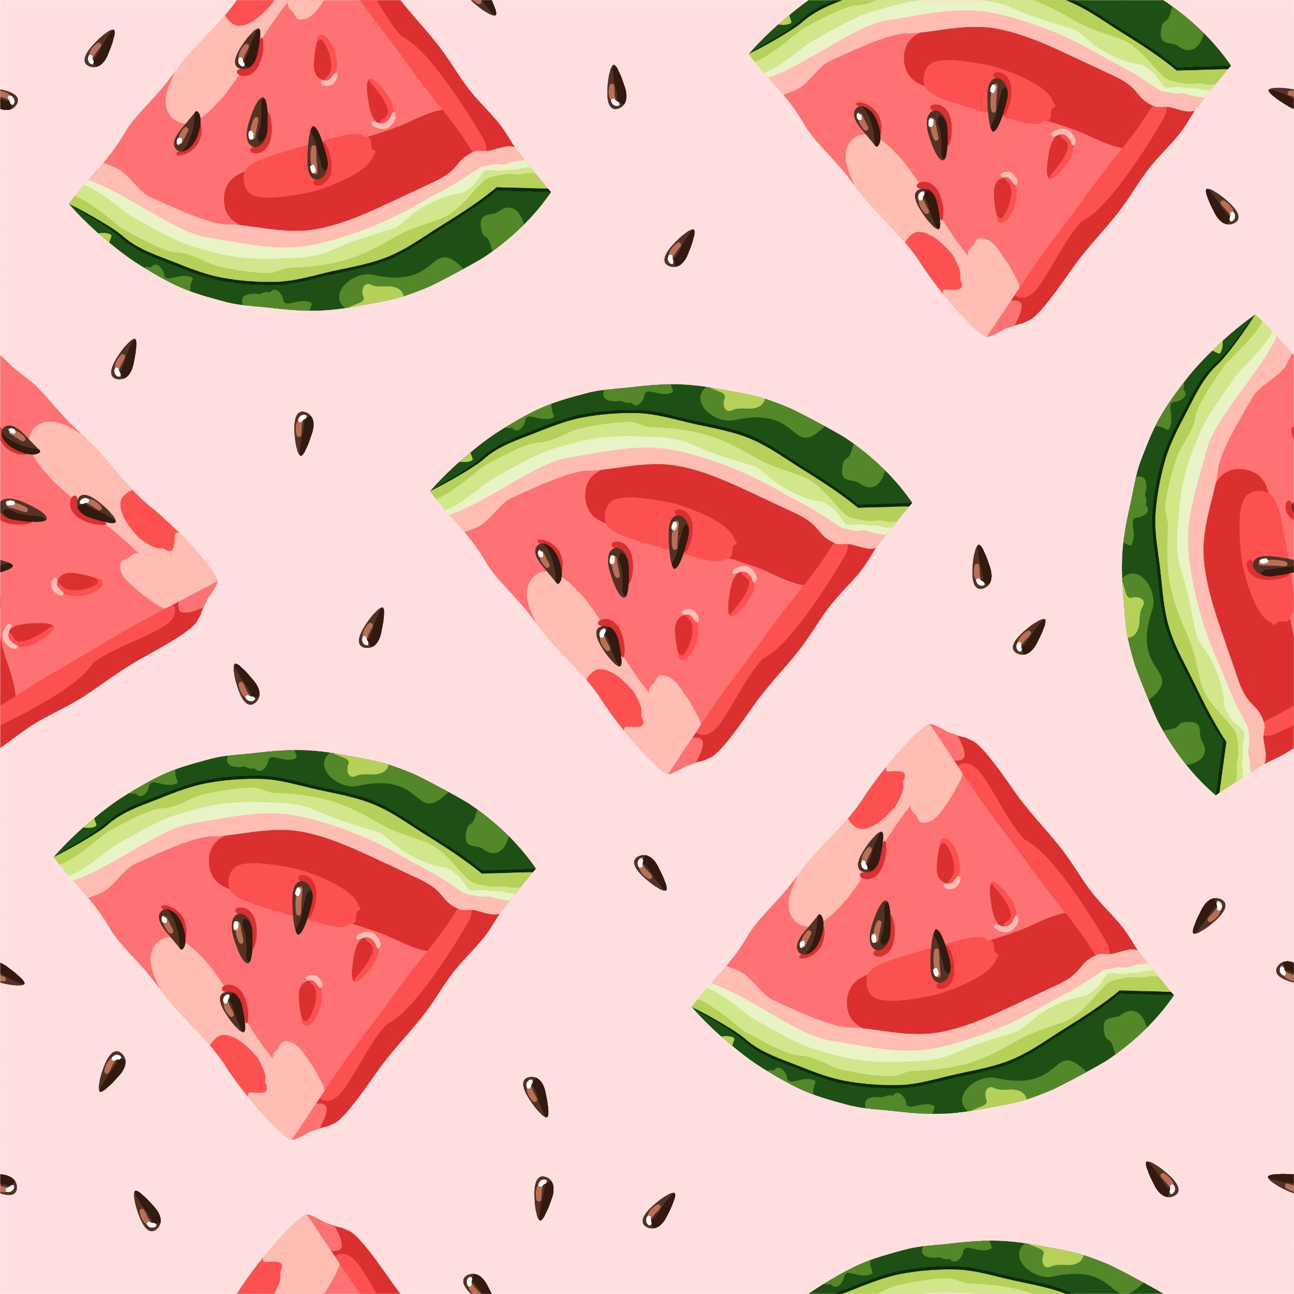
Summer 2023
Rotating Lunch Menu

Monday
Cranberry Chicken Salad – 3 oz  WG Captain’s Crackers – 2 packets each  Green Salad – 1 cup  Fresh Orange - 1 each  Skim Milk – 8 fl. oz. | TACO TUESDAY  Beef & Bean Crunchy Tacos  WG taco shells - 2 each  Mexicorn - 1/2 cup  Fresh Apple - 1 each  Skim Milk – 8 FL oz | Spaghetti Bolognese- 3 oz  WG Spaghetti – 2 oz  Italian Cucumber Salad – ½ cup  Fresh Grapes – ½ cup  Skim Milk – 8 fl. Oz. | Rotisserie Chicken – 1 each  Honey Wheat Roll – 1 each  Kevin’s Baked Beans – ½ Cup  Fresh Pineapple – ½ cup  Skim Milk – 8 fl. Oz. | Buffalo Chicken Enchilada Dip – ½ cup  WG Tortilla Chips – 1 oz  Fresh Corn Salad – ½ Cup  Fresh Banana – 1 each  Skim Milk – 8 fl. Oz.
Chicken Fajita Soft Tacos w peppers and onion  2 oz each  Shredded cheese – ½ oz  WG Flour tortilla – 2 each  Corn Cobbette – 1 each  Fresh Apple – 1 each  Skim Milk – 8 fl. Oz. | Spicy Cajun Chicken & Pasta  4 oz pasta/chicken  WG Penne – ½ cup  Scandinavian Veg – ½ cup  Fresh Strawberries – 1 each  Skim Milk – 8 fl. Oz. | Cheeseburger- 1 each  WG Bun – 1 each  Cole Slaw – ½ cup  Fresh Watermelon – ½ cup  Skim Milk – 8 fl. oz. | Beef Taco Salad – 3 oz taco meat, lettuce, cheese, tomatoes  WG Tortilla Chips – 1 oz  Green Salad – 1 Cup  Fresh Grapes – ½ Cup  Skim Milk – 8 fl. Oz. | BBQ Chicken- 1 each  Honey Wheat Roll – 1 each  Southern Style Green Beans – ½ cup  Fresh Orange – ½ Cup  Skim Milk – 8 fl. Oz.
Mediterranean Roasted Chicken Quarters – 3 oz  Honey Wheat Roll – 1 each  Italian Blend Veg – ½ cup  Fresh Orange – 1 each  Skim Milk – 8 fl. Oz. | Asian Chicken Salad w/ Mandarins & Chow Mein Noodles  2 oz chicken  WG Education Crackers – 1 oz  Green Salad – 1 cup  Fresh Apple – 1 each  Skim Milk – 8 fl. Oz. | Philly Cheesesteak  4 oz meat and veg mix  WG Bun – 1 each  Baby Carrots – ½ Cup  Fresh Berries – 1 each  Skim Milk – 8 fl. Oz. | Penne Bolognese  3 oz sauce and meat  WG Spaghetti – ½ cup  Italian Cucumber Salad – ½ cup  Fresh Banana – 1 each  Skim Milk – 8 fl. Oz. | Chicken Soft Tacos w/shredded cheese – 2 oz chicken, ½ oz cheese, lettuce, tomatoes  WG Tortillas – 2 each  Fresh Corn Salad (Esquites) – ½ cup  Fresh melon – ½ cup  Skim Milk – 8 fl. Oz.
Cheeseburger- 1 each  WG Bun – 1 each  Potato Wedges – ½ cup  Fresh Apple – 1 each  Skim Milk – 8 fl. oz. | Taco Tuesday  Beef & Bean Crunchy Tacos  WG taco shells - 2 each  Mexicorn - 1/2 cup  Fresh Orange -1 each  Skim Milk – 8 FL oz | SW Chicken Salad (cold) w/ black beans and corn salsa – 2oz chicken, 1 oz black beans and corn  WG Crackers – 1 oz  Green salad – 1 Cup  Fresh Banana – 1 each  Skim Milk – 8 fl. oz. | Smokey Chicken Quarter- 1 each  WG Macaroni Salad – ½ cup  Corn Cobbette – 1 each  Fresh Grapes – ½ Cup  Skim Milk – 8 fl. oz. | Breaded Chicken Sandwich - 1 each; 1 slice American cheese  WG Bun – 1 each  Fresh Celery – ½ cup  Fresh Berries – ½ Cup  Skim Milk – 8 fl. oz.

Tuesday

HAPPY SUMMER!!

Wednesday

Thursday

Ages: 6-18

Fri

