SAFE HANDLING GUIDELINES FOR SHELL EGGS

Before accepting shell eggs, check and confirm that the following standards are in place to ensure the products are from an approved source and meet requirements outlined below.

- Overview/Background:
The FDA Egg Safety Rule requires preventive measures during the production of eggs in poultry houses and requires subsequent refrigeration during storage and transportation.

Egg-associated illness caused by Salmonella is a serious public health problem. Infected individuals may suffer mild to severe gastrointestinal illness, short-term or chronic arthritis, or even death.

Under the requirements of this rule, egg producers must implement safety standards to reduce risks associated with Salmonella Enteritidis (SE) including:
  - Controlling pests, rodents, and other hazards
  - Purchasing chicks and hens from suppliers who control for Salmonella
  - Meeting environmental testing and cleanliness provisions
  - Storing and transporting eggs at refrigerated temperature of 45 °F or lower
- Whole Shell Egg Donation Standards
- Be familiar with your state’s laws before accepting raw shell eggs from donors
  - Refer to your State’s Department of Agriculture website or use this link as an initial resource by State reference
https://nerous.org/state-laws-regulations.php
2. Verify that the whole shell egg donor is a licensed food business and/or producer to distribute or sell whole shell eggs for human consumption

- Producer/Packer or Retail Distribution Center Donation Requirements:
- Verify during receiving that donated eggs were transported under refrigerated air temperatures of 45°F or lower
  - Check the interior air temperature of the truck trailer or cargo box with a calibrated thermometer or temperature gun
- Verify cases and cartons of eggs are properly packaged and labeled with:
- Distributor Packer Name and Address
- Statement of identity (Eggs)
- Net Contents
- Keep Refrigerated Statement posted on carton or case
- Egg Safe Handling Instructions posted on each carton
- Store and distribute eggs under refrigerated temperatures of 41° F or lower

- Retail Store Donation Requirements:
- Verify that the shell eggs were retrieved or received at refrigerated temperatures of 41°F or lower using a calibrated thermometer
- Verify that the egg cartons are properly labeled (as noted in C2 above)
  - When the cases or cartons are labeled with a code (sell-by, best-by, use-by) date, verify the eggs meet the retail store donation guidance.
- Inspect cartons of eggs for damage or residual damage (wet or dry yolk)
  - Remove and discard damaged eggs or eggs in contact with wet/dry yolk
  - Donate the remaining eggs in their original carton
  - Do not repackage eggs unless the food bank has a State license to repack shell eggs
- Store and transport eggs in their original cartons under refrigerated temperature of 41° F or lower.
  - Distribute eggs within 3 weeks for best quality.

EGG SAFE HANDLING INSTRUCTIONS:
To prevent illness from bacteria: Keep eggs refrigerated at 41°F or lower, cook eggs until yolks are firm, and cook foods containing eggs thoroughly.

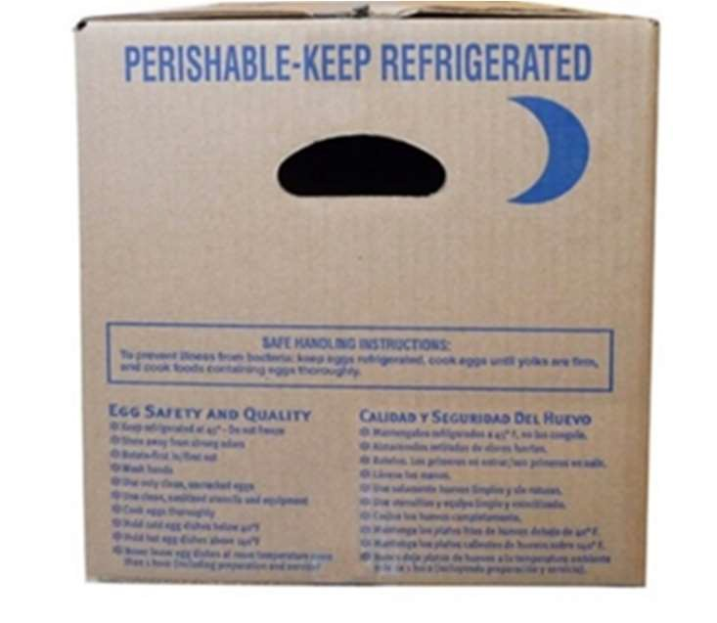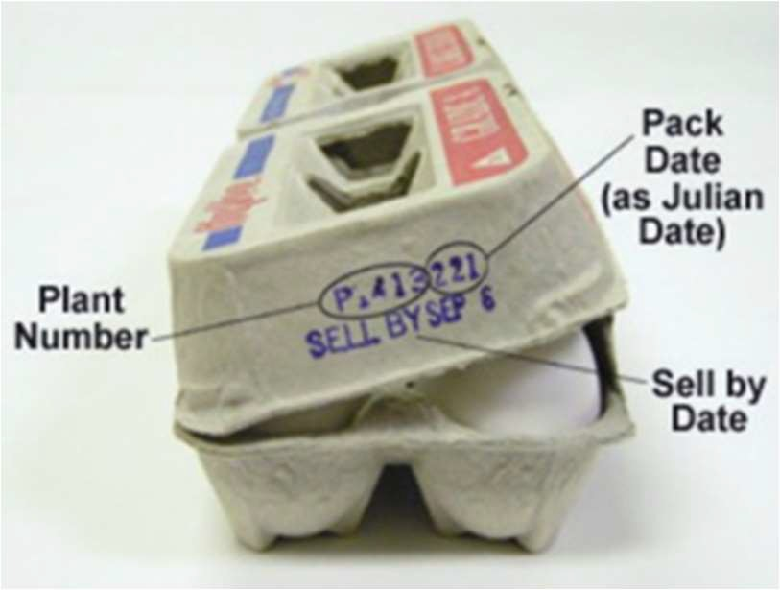

Key Resources:

https://www.fda.gov/food/buy-store-serve-safe-food/what-you-need-know-about-egg-safety

https://www.utahfoodbank.org/wp-content/uploads/2017/02/Complete_Guide_09-25-12.pdf

https://unitedegg.com/egg-terms/

